**CCP Plugins User Guide**

# CCP-Plugins:

# List of Eclipse plugins

* CCP-CRUDConnectorGen_3.0.0.201608171208.jar
* CCP-MicroAppCodeGen_3.0.0.201608171208.jar
* CCP-MicroServiceCodeGen_3.0.0.201608171208.jar
* CCP-EditDependenciesPlugin_3.0.0.201608171208.jar
* CCP-ValidateConfigurationPlugin_3.0.0.201608171208.jar
* CCP-ServicesPlugin_4.0.0.201608171208.jar
* CCP-HelpContent_3.0.0.201608171208.jar

# List of CLI plugins

* CLI-CRUD-ConnectorCodeGen_3.0.0.201608171208.jar
* CLI-MicroAppCodeGen_3.0.0.201608171208.jar
* CLI-MicroServiceCodeGen_3.0.0.201608171208.jar

# *How to get the Plugins?*

To install the plugin go to,

STS Help 🡪 install new software 🡪 click on Add 🡪 Enter below Url

*http://ra.gcb.nsroot.net/release/ccp/*

Click ok.

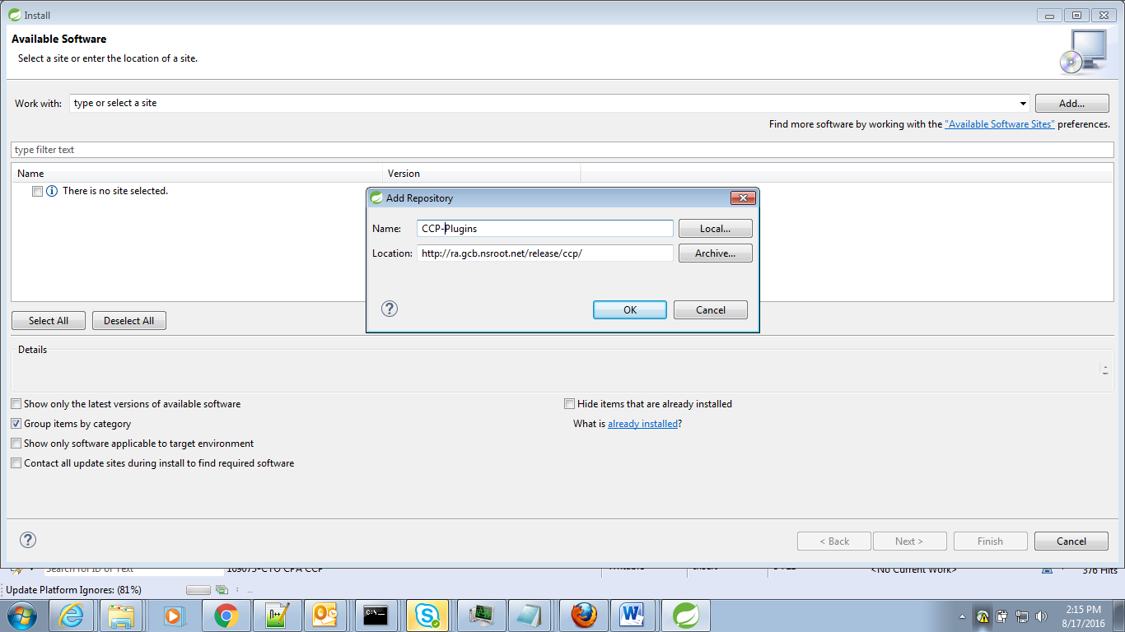

Select ‘ccpjetpack’ 🡪Next

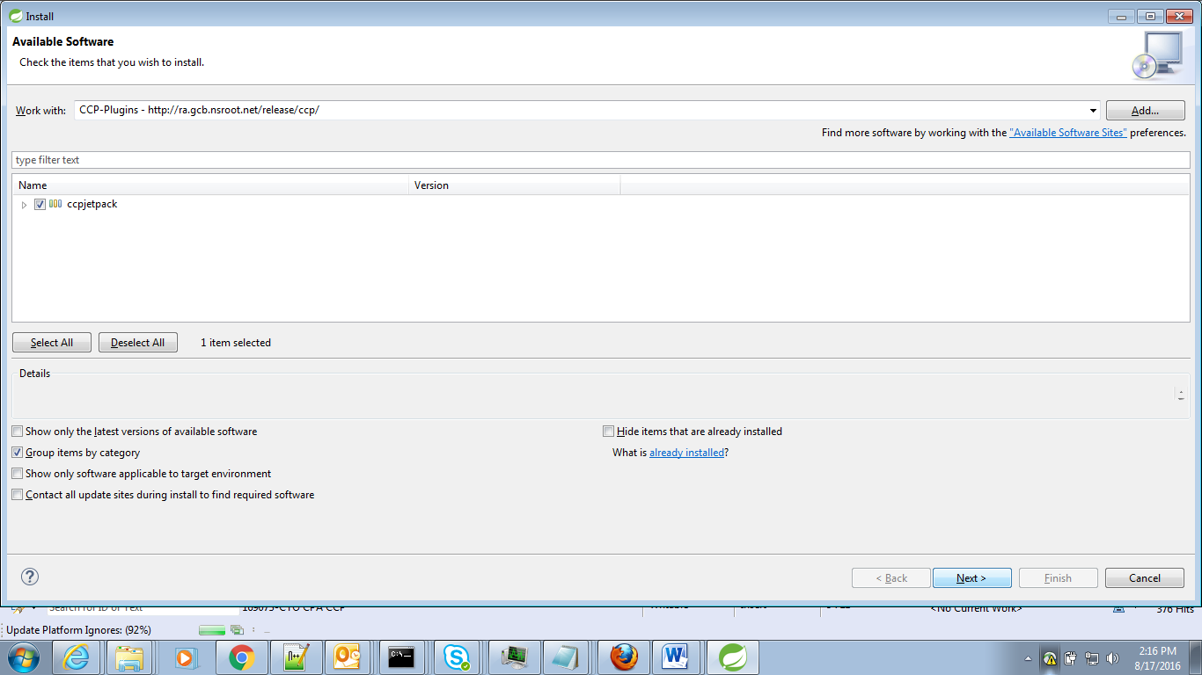

Accept the terms and conditions 🡪Finish

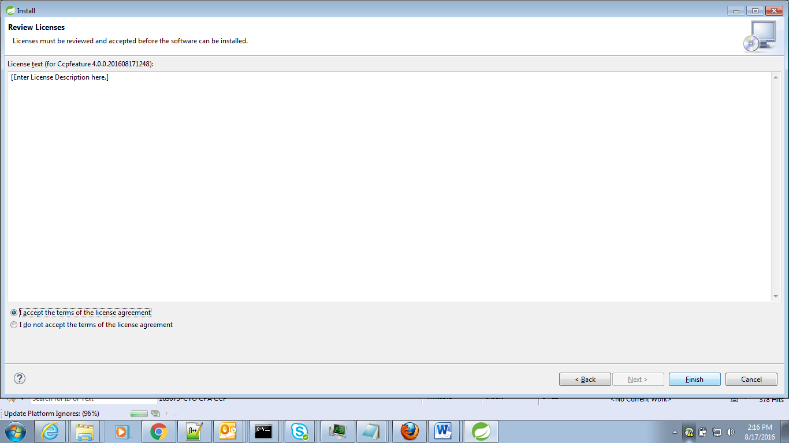

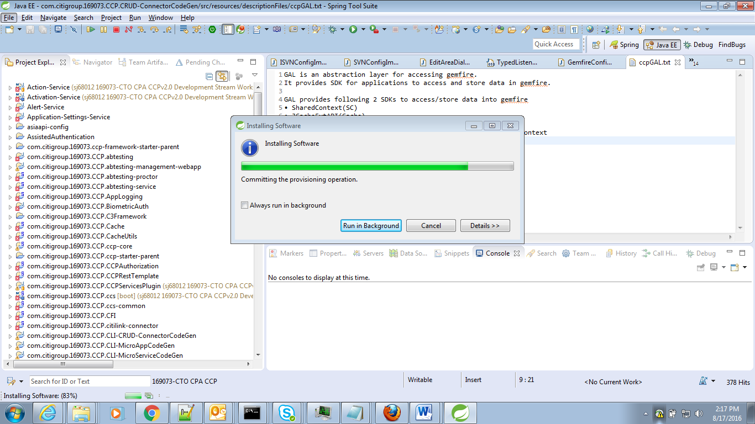

It will prompt to restart. Do restart to complete the installation.

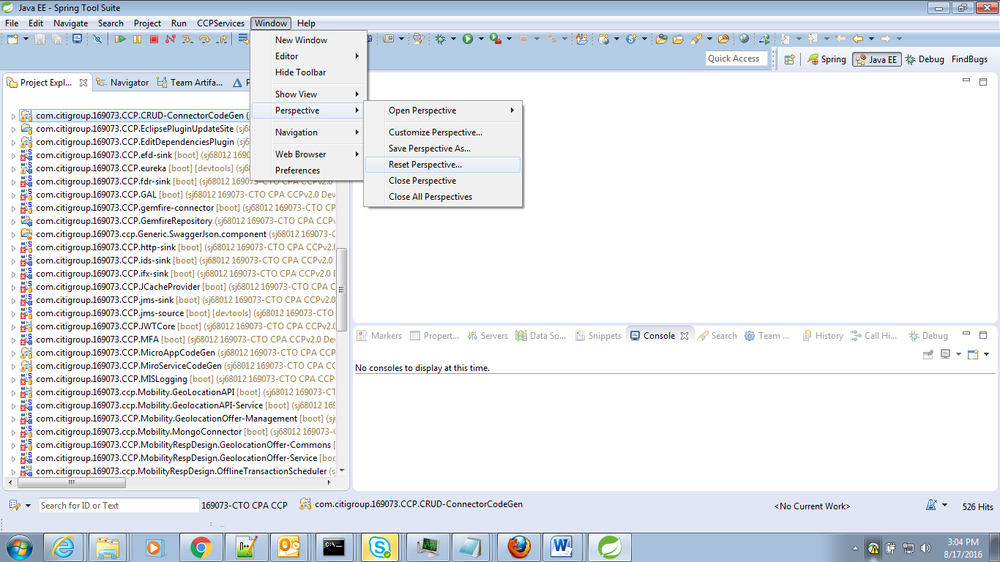

Once Rest is done, theses plugins will be highlighted in New Menu

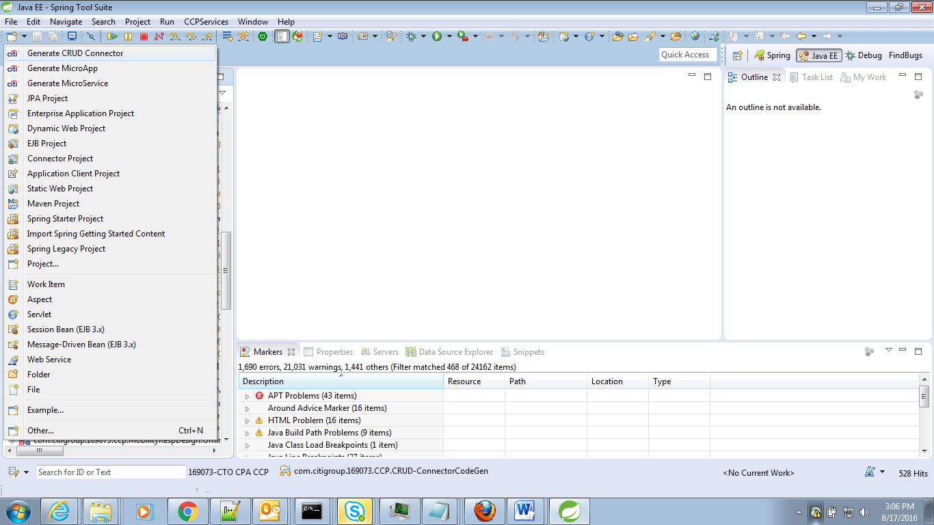

It can be access at New🡪project🡪 CCP Code Generator

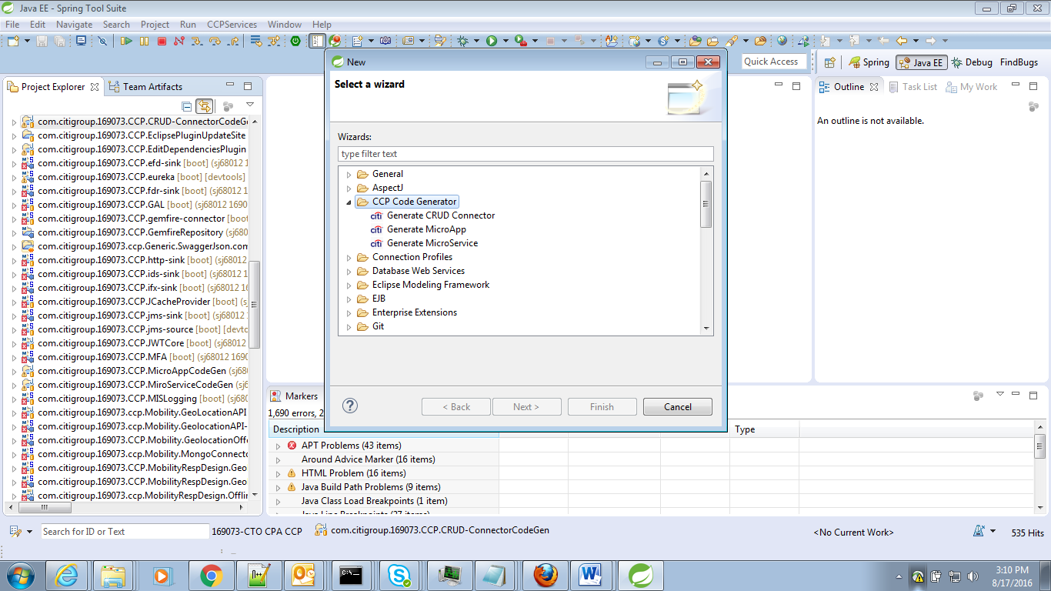

# *About NGA Code Generator*

On click of any of the generators, a new wizard will prompt for enter project details.

**Name** : This is the Project name. User should enter his name, using which the code generator will create a MicroApplication. This name is used to represent the project in pom.xml file

**Boot Version:**  This is the Spring boot version. By default it is 1.3.2.RELEASE. It is an editable text box where user can enter the required Spring boot version. Based on this boot version pom.xml is built.

**Packaging**: jar/war

**GroupID**: This is the GroupID of the application. User should follow Citi standards while defining this. This get reflects in pom.xml file

**ArtifactID**: This is the ArtifactID of the application This get reflects in pom.xml file.

**Version**: This is the version of the application. This get reflects in pom.xml file. With this version the jar will be created.

**Description**: This is the description of the application. This get reflects in pom.xml file

**Profile**: These profile names are for reading the configuration file from Config Servers. These profile details is added to the <<ApplicationName>>.yml file.

**Port Number:** This is the port number in which the MicroApp/MicroService/Crud Connector will run.

**Dependencies**: These are available CCP libraries. Required library files can be selected here. The corresponding dependency entries/annotation/autowiring fields in Spring Application class /Controller class, will be taken care by the NGA code generator.

**Gemfire Url:** Here the Gemfire connection url has be to entered. Using which in <<ApplicationName>>.yml gemfire configurations will be added. If User doesnt enter any details, by default platform DIT url will added.

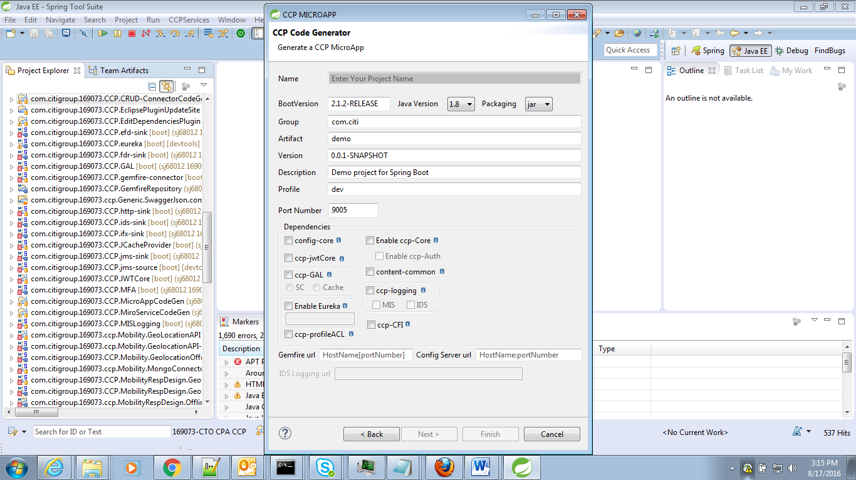

Each CCP-Libraries are provided with the Info tooltip. This will give a short description of the libraries.

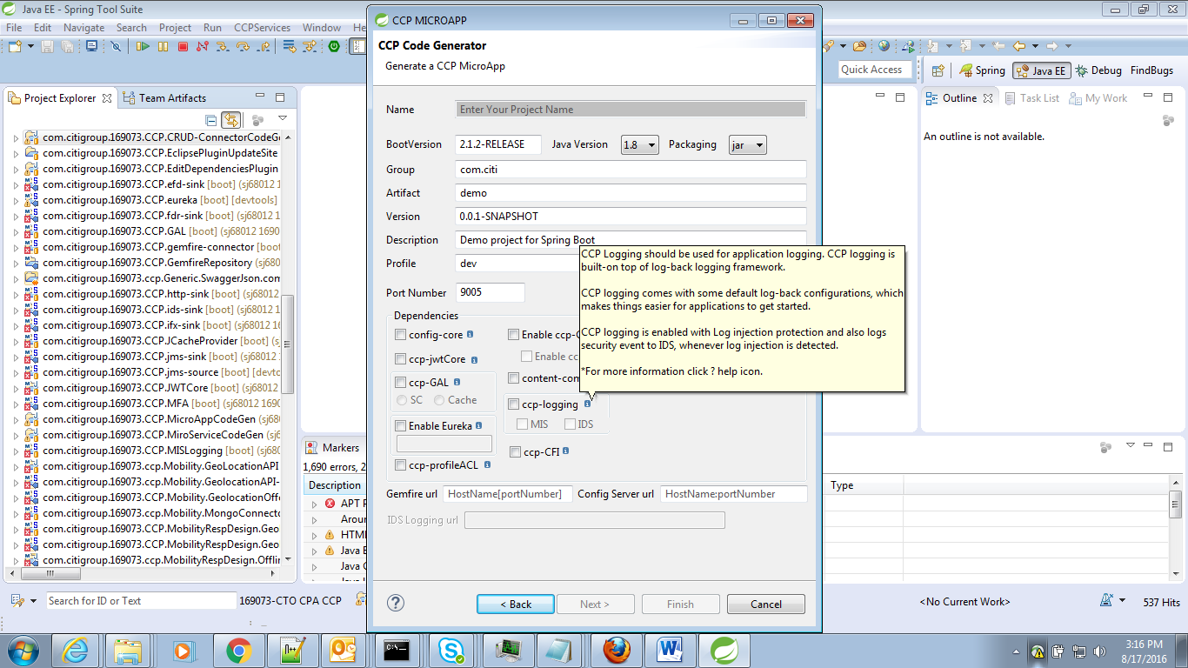

For more information on CCP-Libraries , Click ‘Help’ icon. Extended Help wizard will get open.

This will list the available CCP- Libraries and their description, configuration details etc.

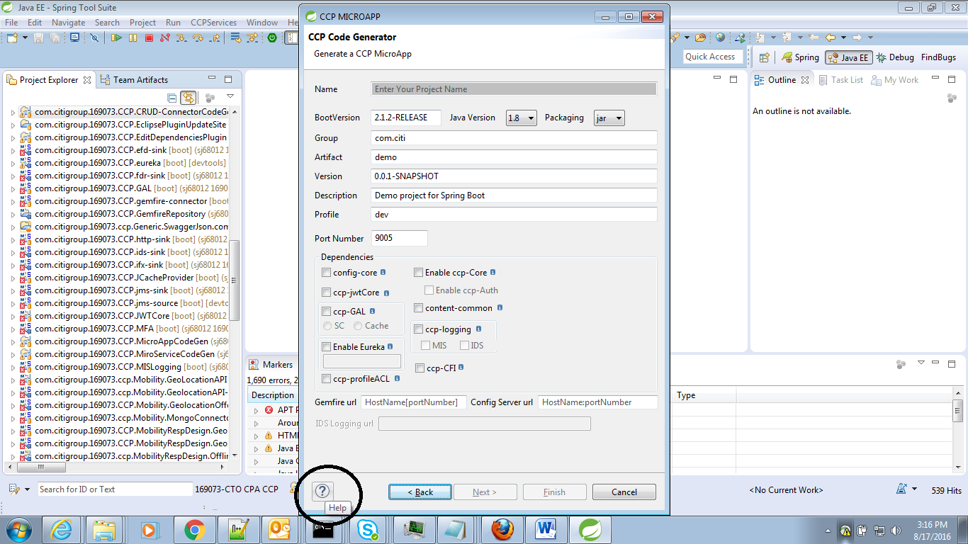

Onclick of Help button,

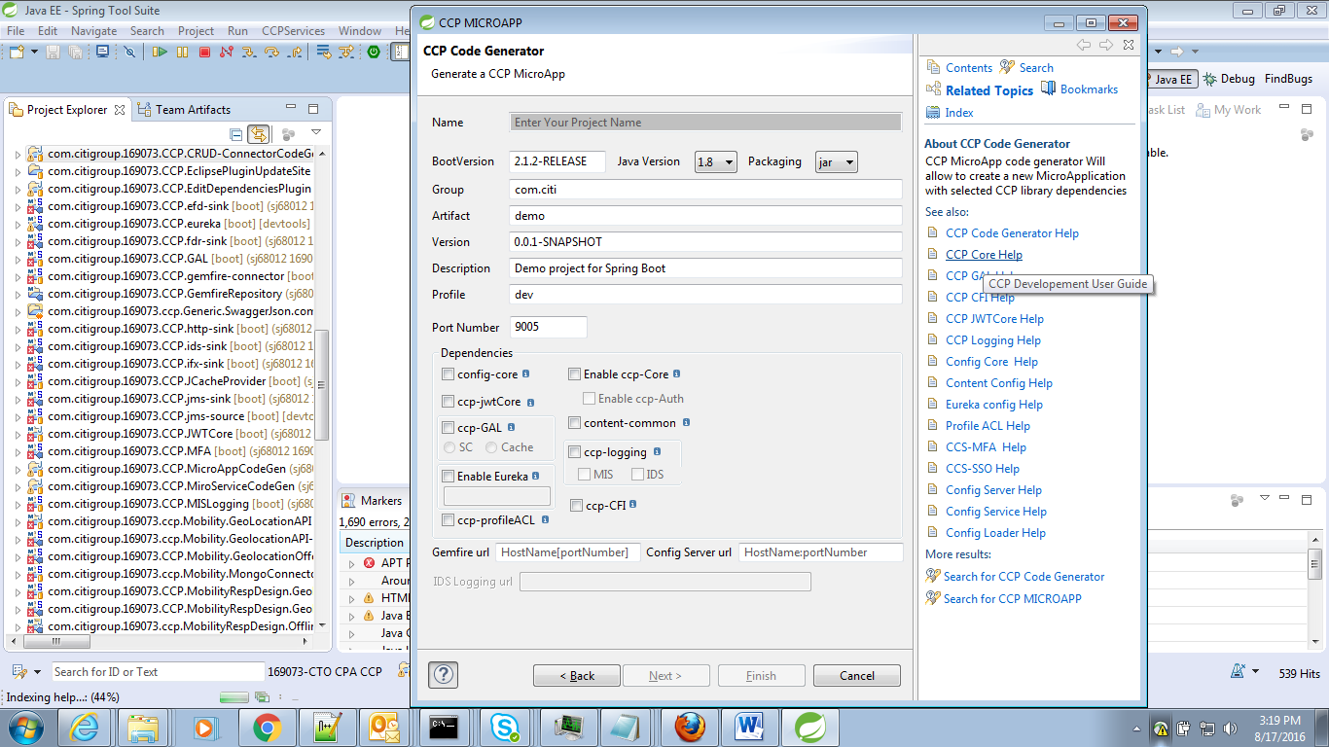

Here on click of Config-Core help link, config-core description is getting displayed.

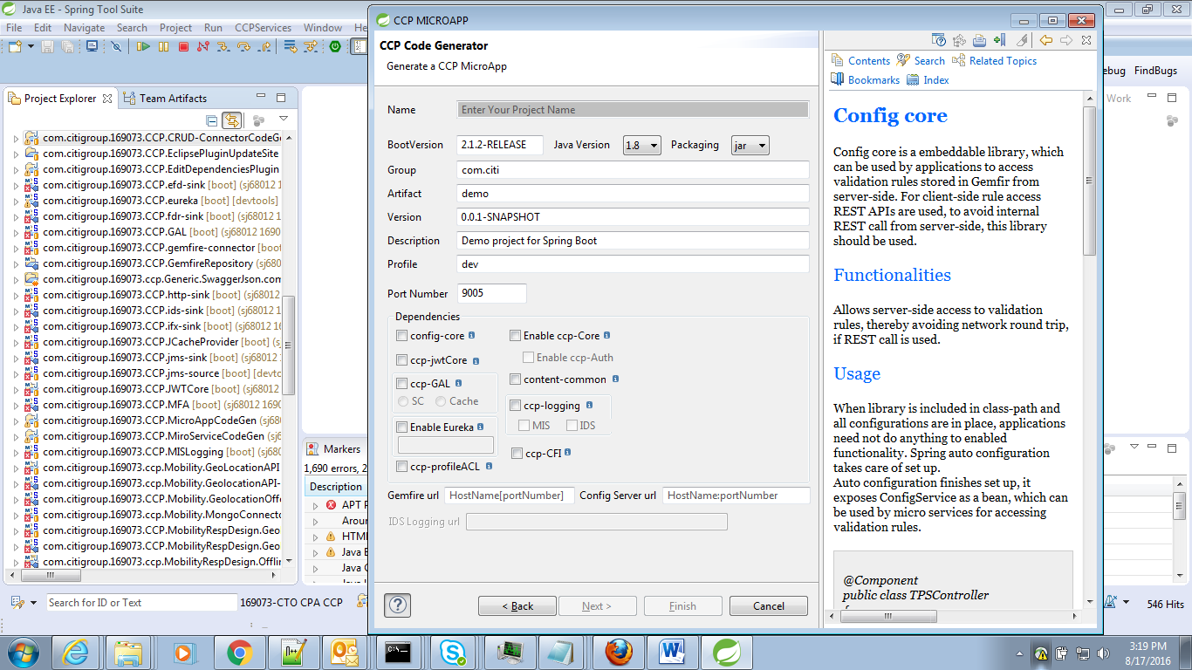

When the required details are entered, Next button will get enable.

The second page of the wizard will prompt for controller class name, package details, and different REST urls which the application going to have.

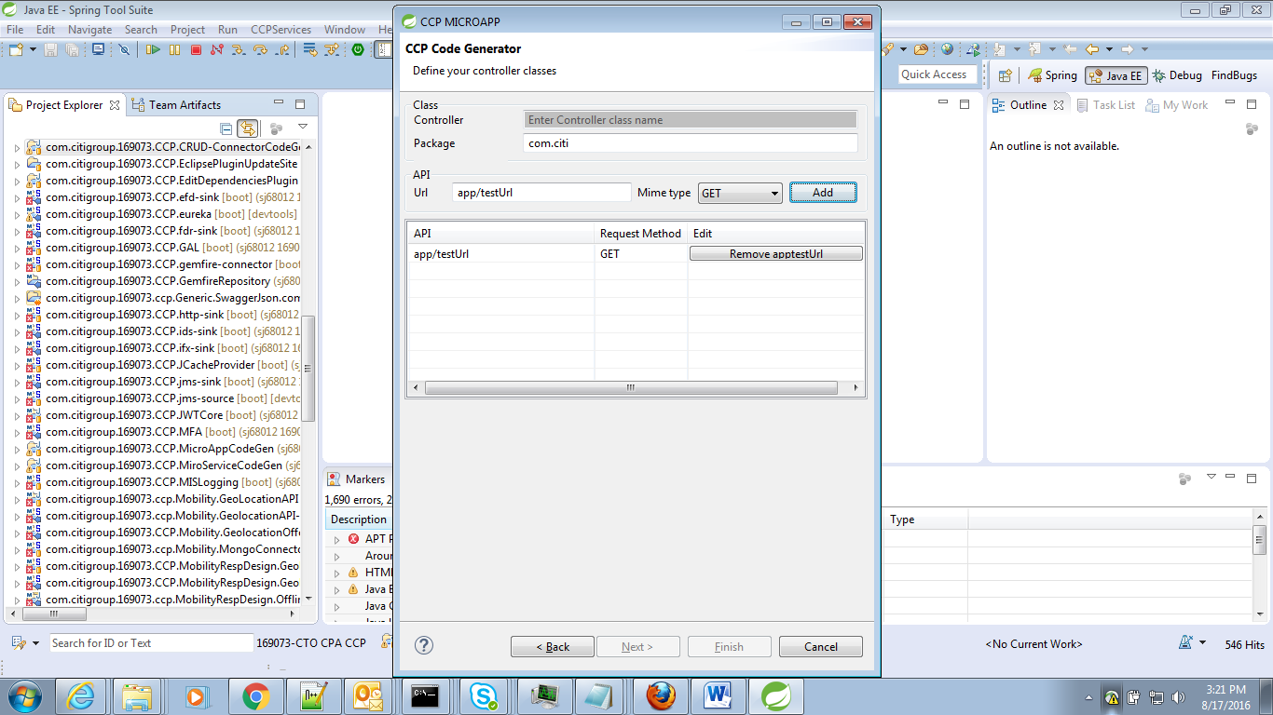

Once entering these, click ‘Finish’ button. The Project will be created and available in the workspace.

# *CPP Micro Application Creation:*

Now lets see how to create Sample Micro-Application.

Micro-App code generator will create the following Classes in the developer defined package.

•         SpringBoot Main Application Class

•         Controller

•         Request and Response Bean

•         Formatter

•         Validator

•         Bootstrap.yml

•         <ApplicationName>.yml

•         pom.xml

Select Generate MicroApp and click ‘Next’.

The Wizard will prompt to enter details for Project creation.

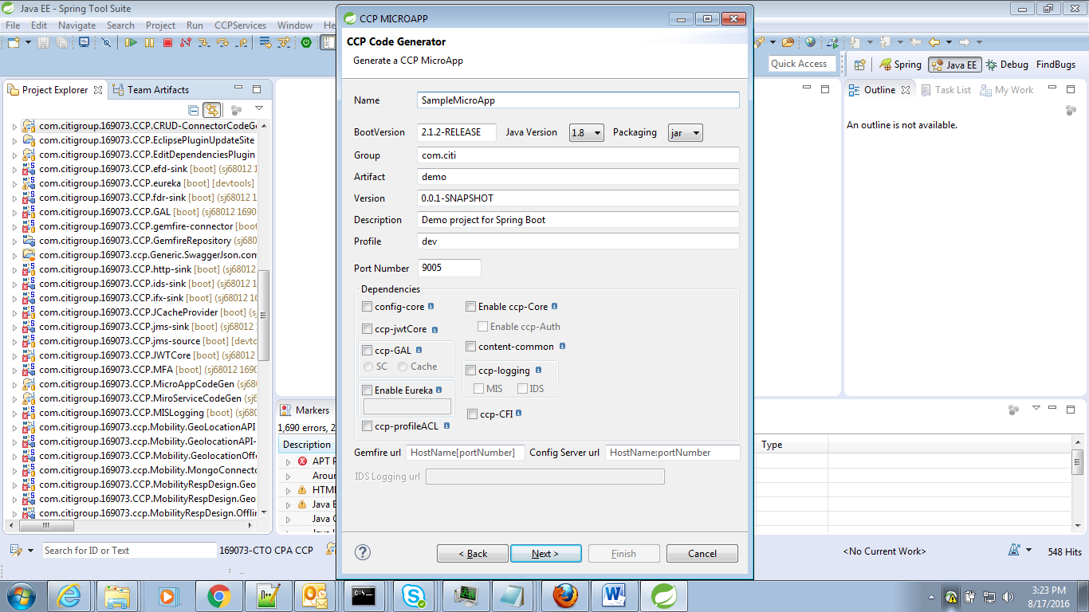

After entering these details click ‘Finish’.

Now the Micro-Application will get created with given folder structure and with required files.

Pom.xml file will be created with default dependencies and with the user selected CCP libraries.

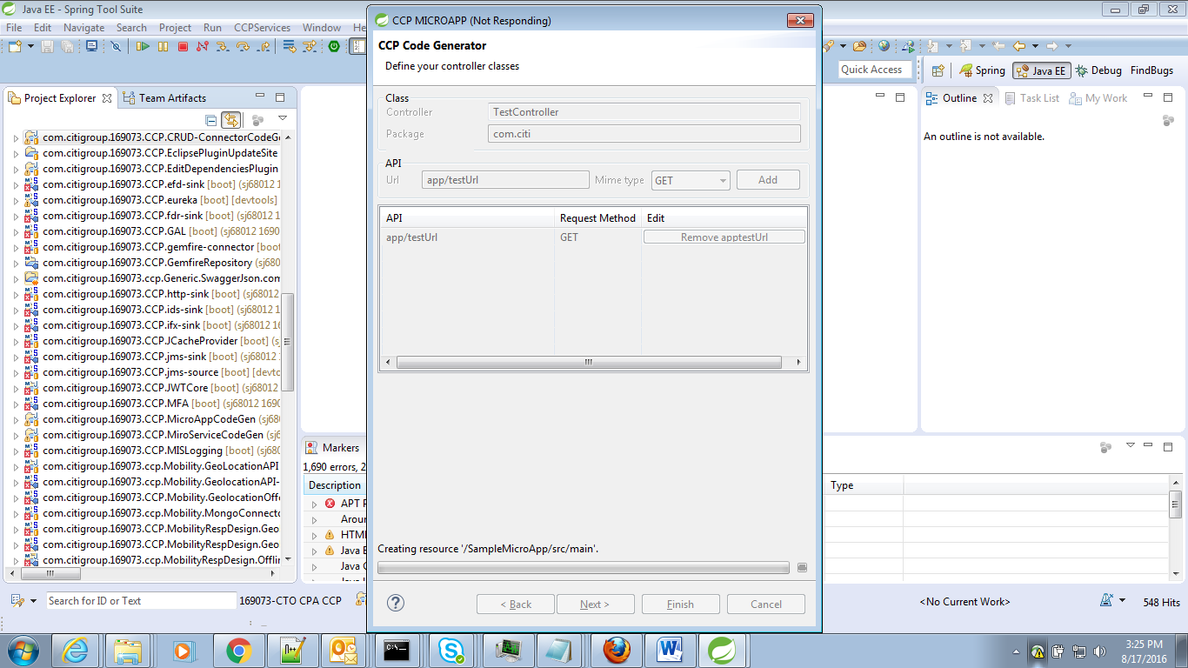

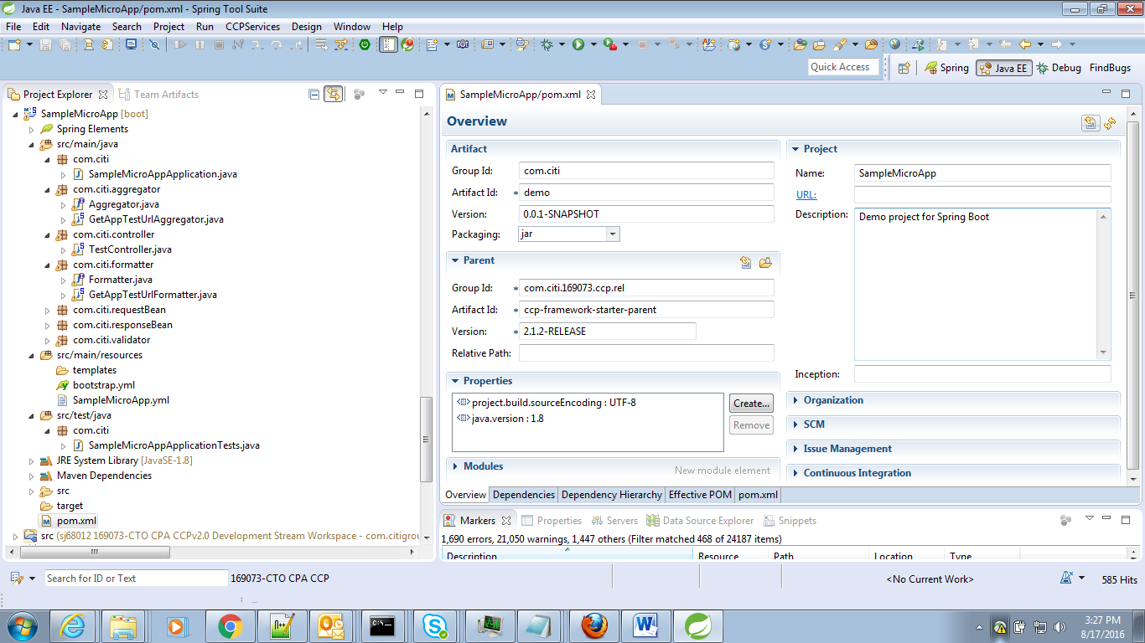

Selected Dependencies,

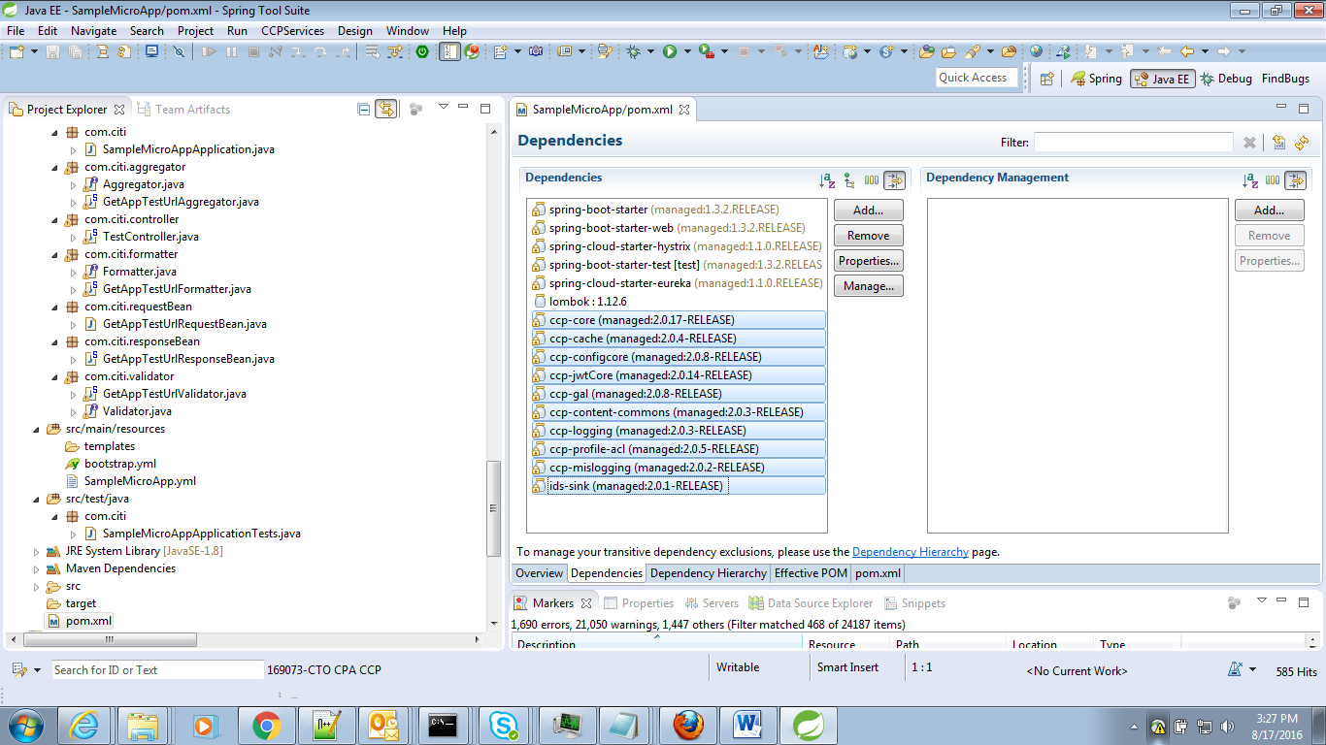

bootstrap.yaml and <ApplicationName>.yaml will be created with user given data under resources folder

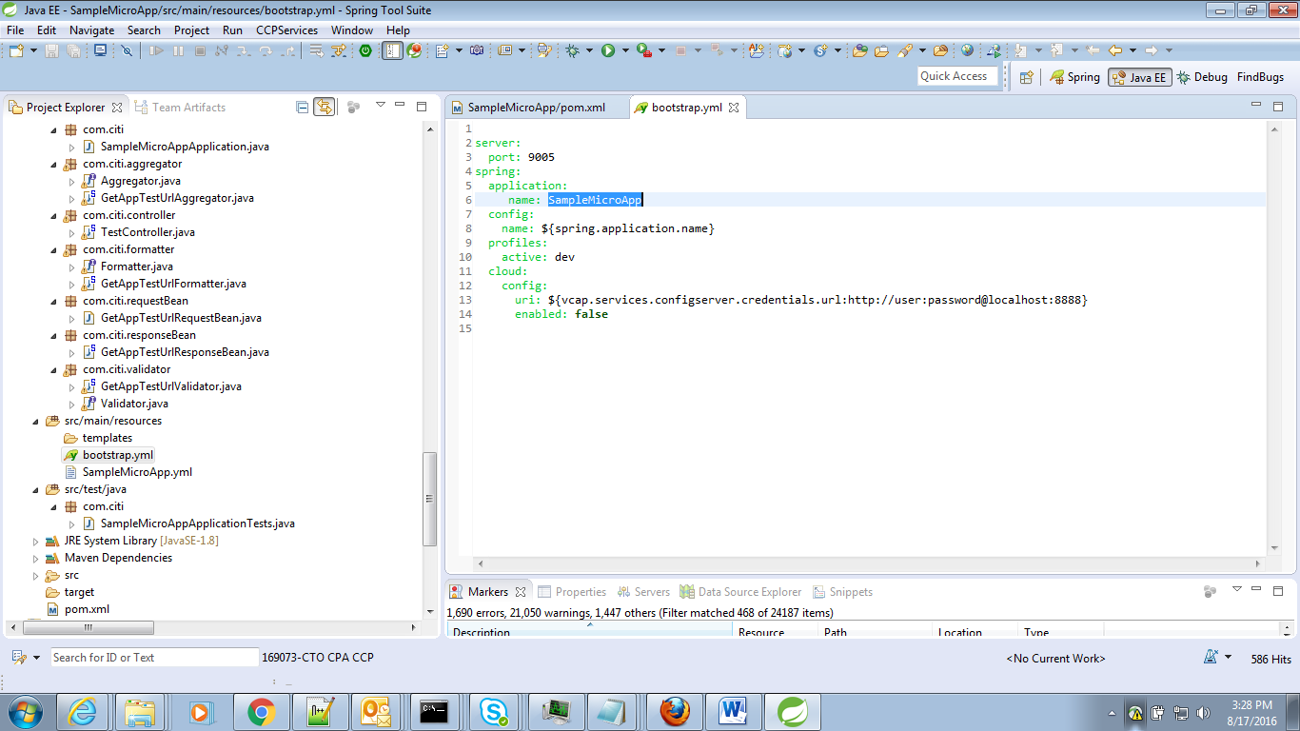

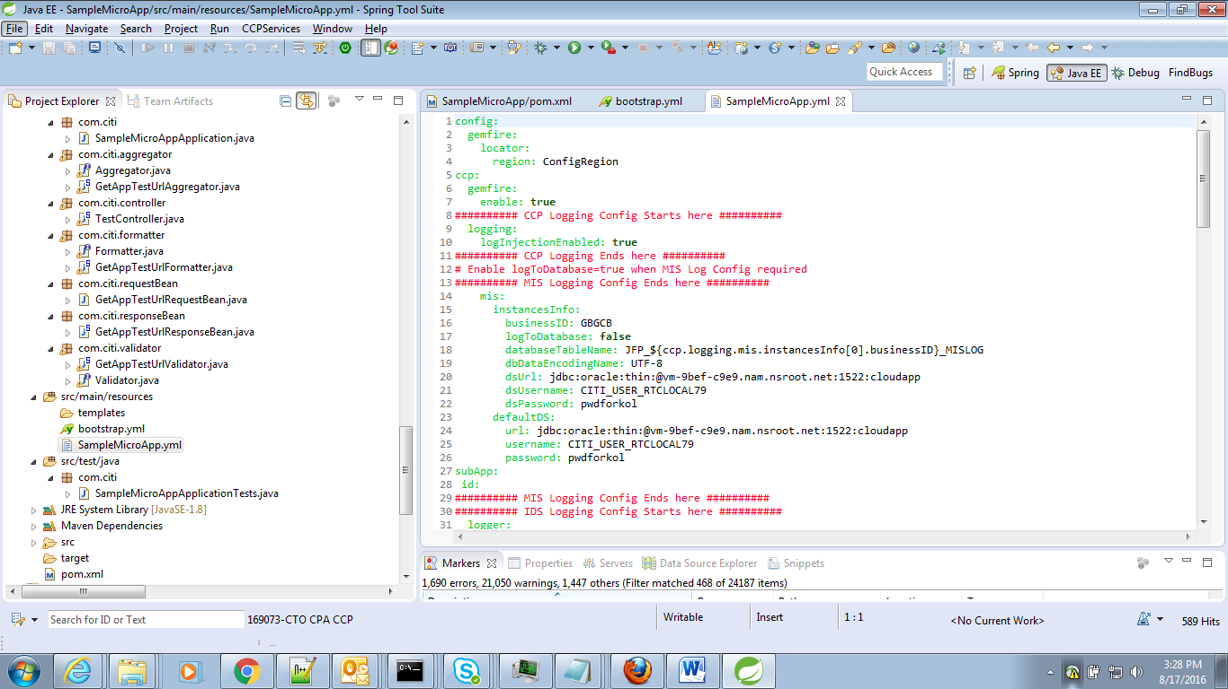

SpringBoot Application Class,

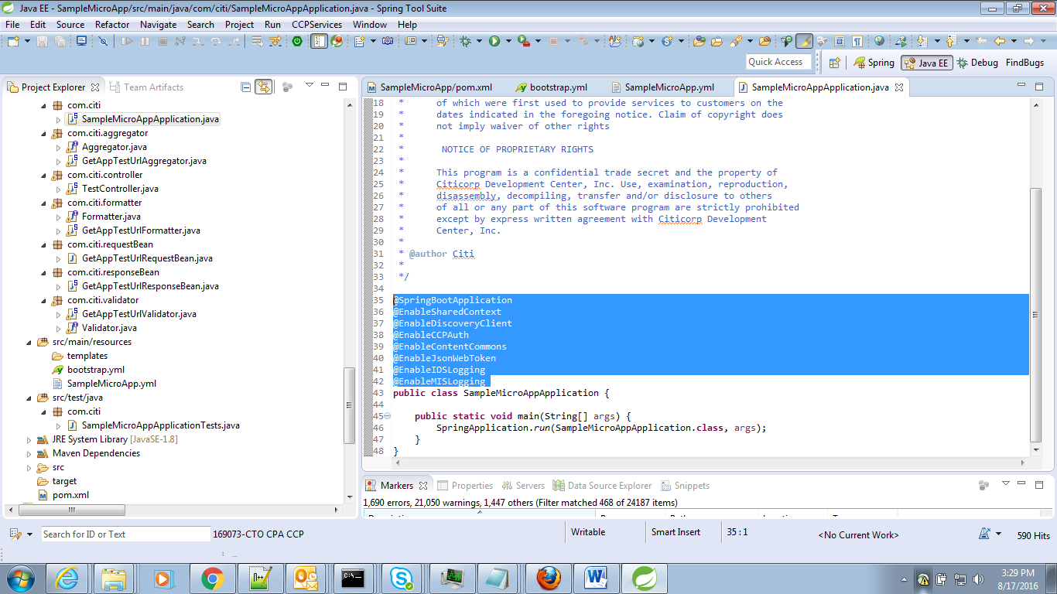

Controller Class,

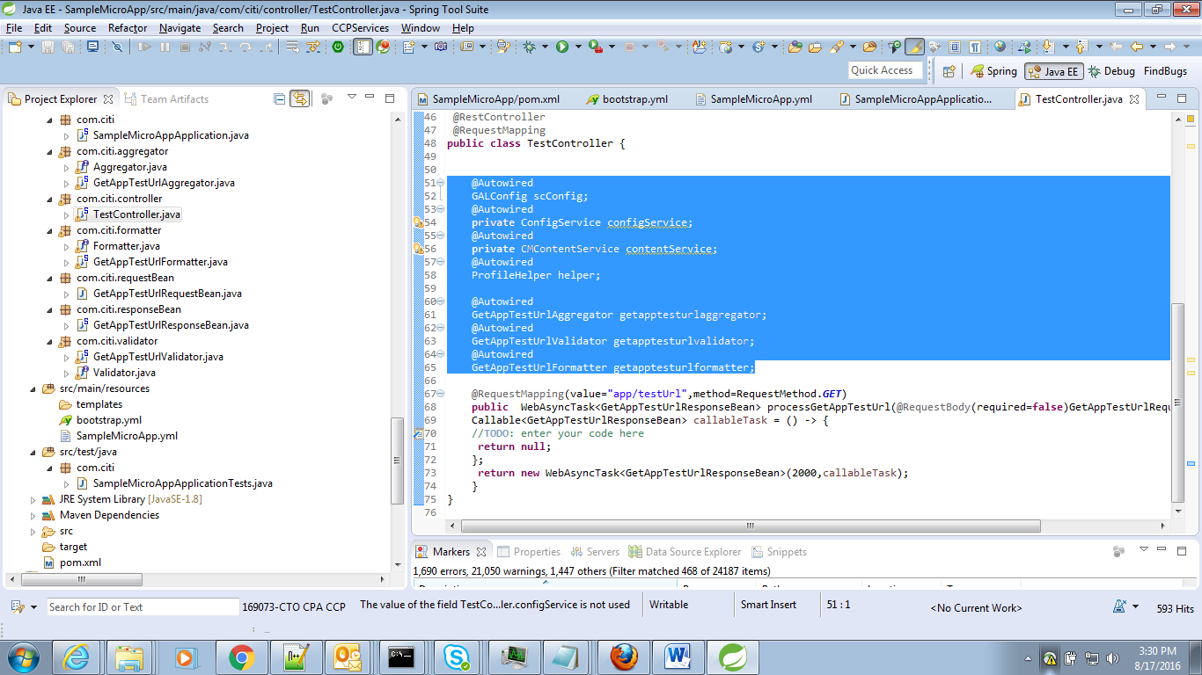

# *CCP MicroService Code Generator:*

The MicroService App generator generates a microService with the user entered details.

MicroService code generator will create the following Classes in the developer defined package.

•         SpringBoot Main Application Class

•         Controller

•         Domain

•         Domain Model

•         Infrastructure data , messaging, restsv, transformationrules, utilities, websv

•         dbcreation.sql

•         Bootstrap.yml

•         <ApplicationName>.yml

•         pom.xml

# 

# 

# *NGA CRUD Connector Code Generator:*

This is for creating different CRUD Connectors like JMS, TPS etc. In the CCP-Dependencies, we can see backends like ccp-tps and cpp-jms libraries available.

After entering these details on click of ‘Next’, second page of the Wizard will get display which will expect Controller class name, package details and REST urls details

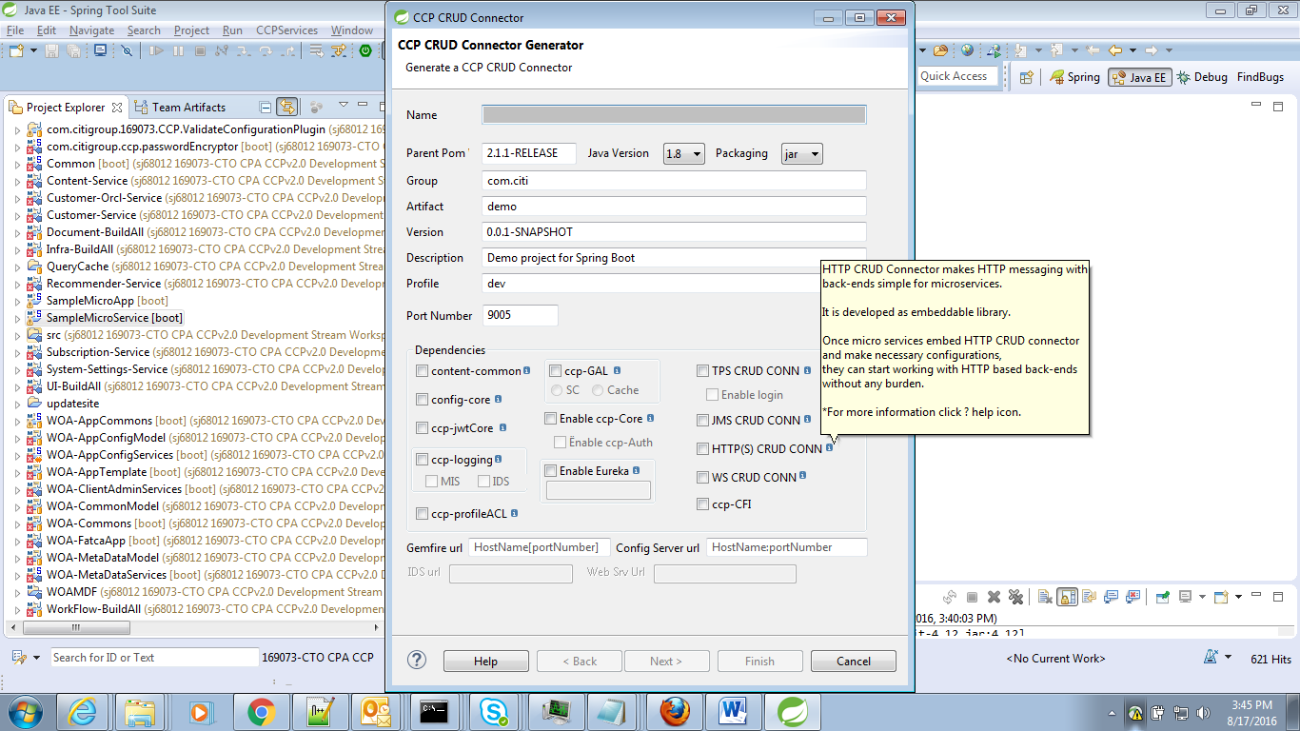

OnClick of Finish, CRUD Connector project will get create with a Springboot Main class and Controller class.

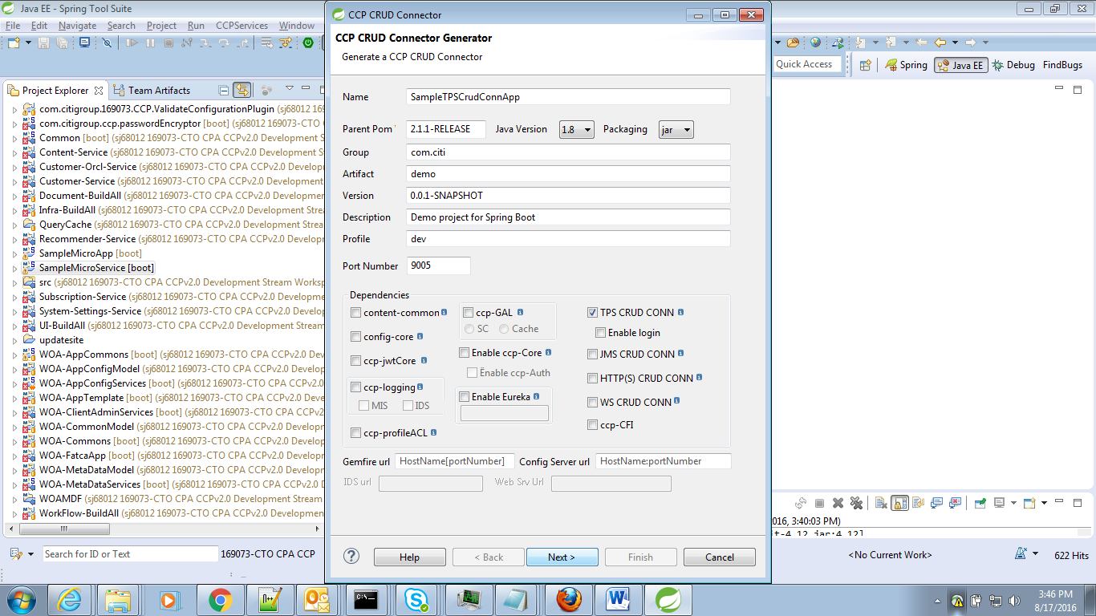

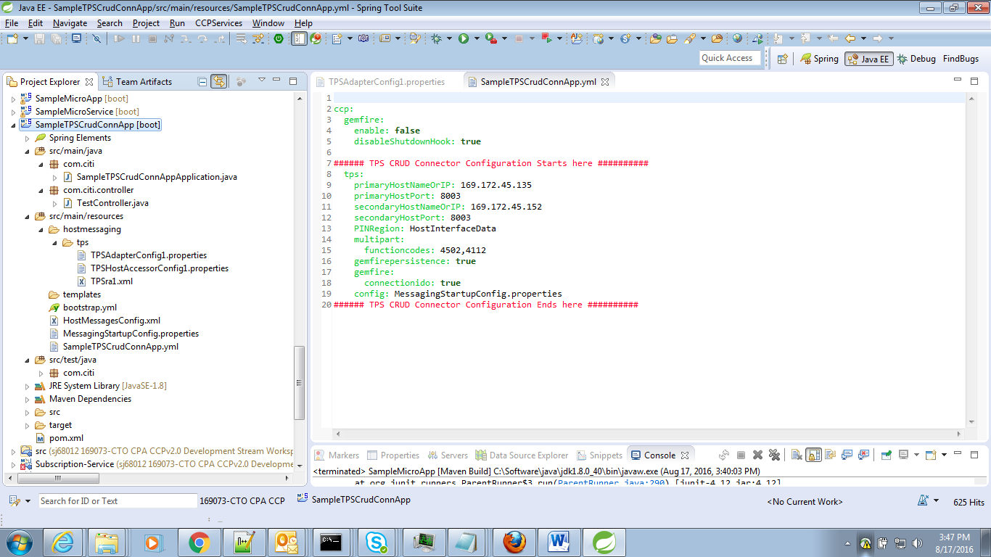

Here enabling TPS will create the tps related configuration files and corresponding Annotations in boot class.

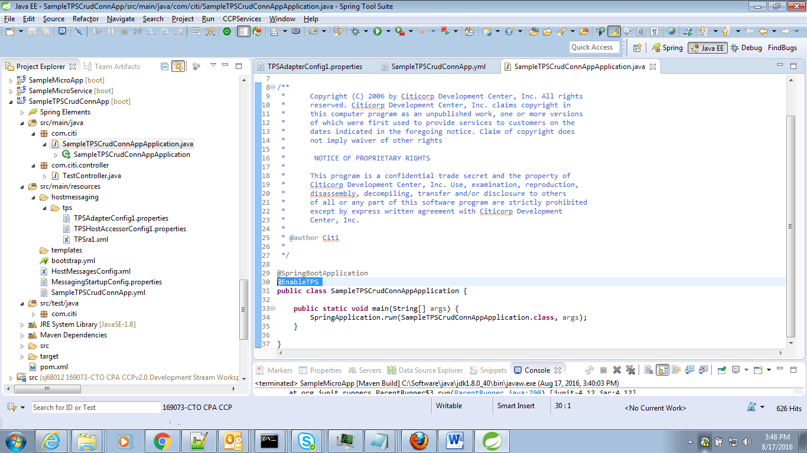

The Controller class will have below autowired fields.

*@Autowired*

*MessageRouter router;*

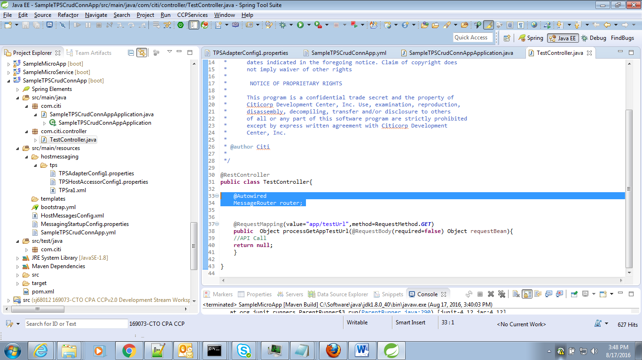

Below are the TPS Configuration files,

*/src/main/resources/hostmessaging/ckm/eracom/EracomCKMconfig.properties*

*/src/main/resources/hostmessaging/tps/TPSAdapterConfig1.properties*

*/src/main/resources/hostmessaging/tps/TPSHostAccessorConfig1.properties*

*/src/main/resources/hostmessaging/tps/TPSra1.xml*

*/src/main/resources/encrypter2.properties*

*/src/main/resources/HostMessagesConfig.xml*

*/src/main/resources/MessagingStartupConfig.properties*

In <<ApplicationName>>.yml file, required tps host details are added

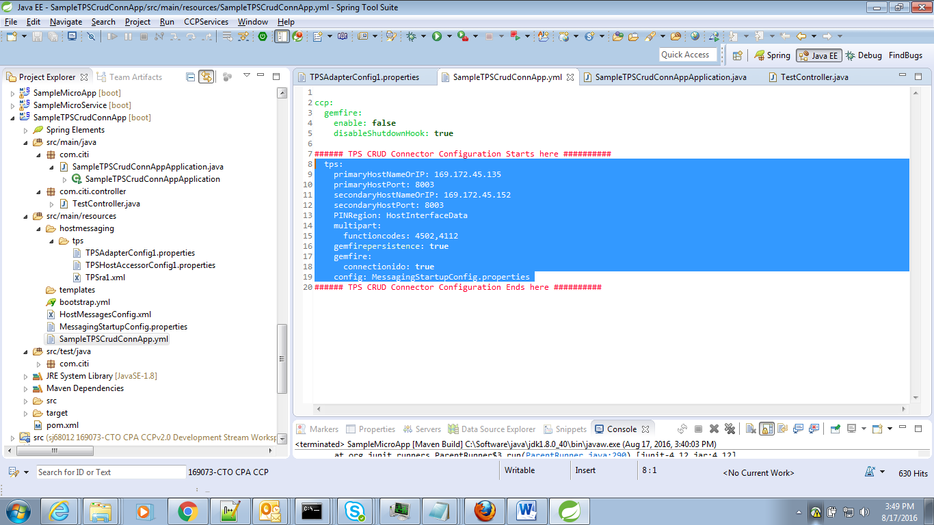

*Dependencies,*

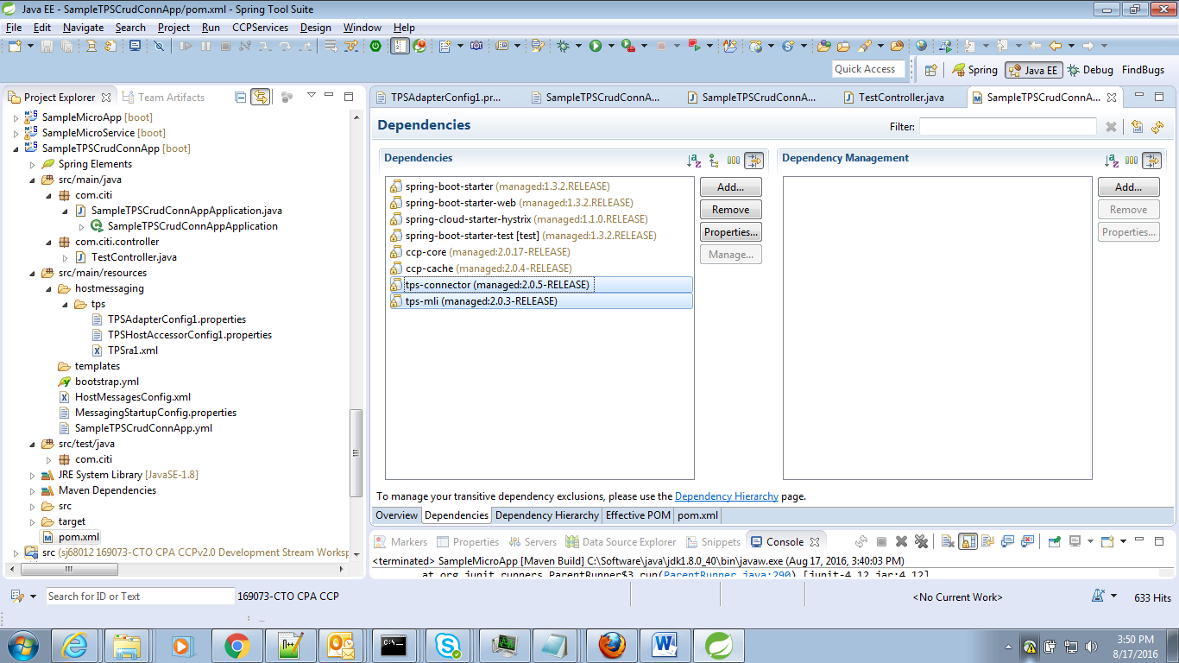

JMS Application:

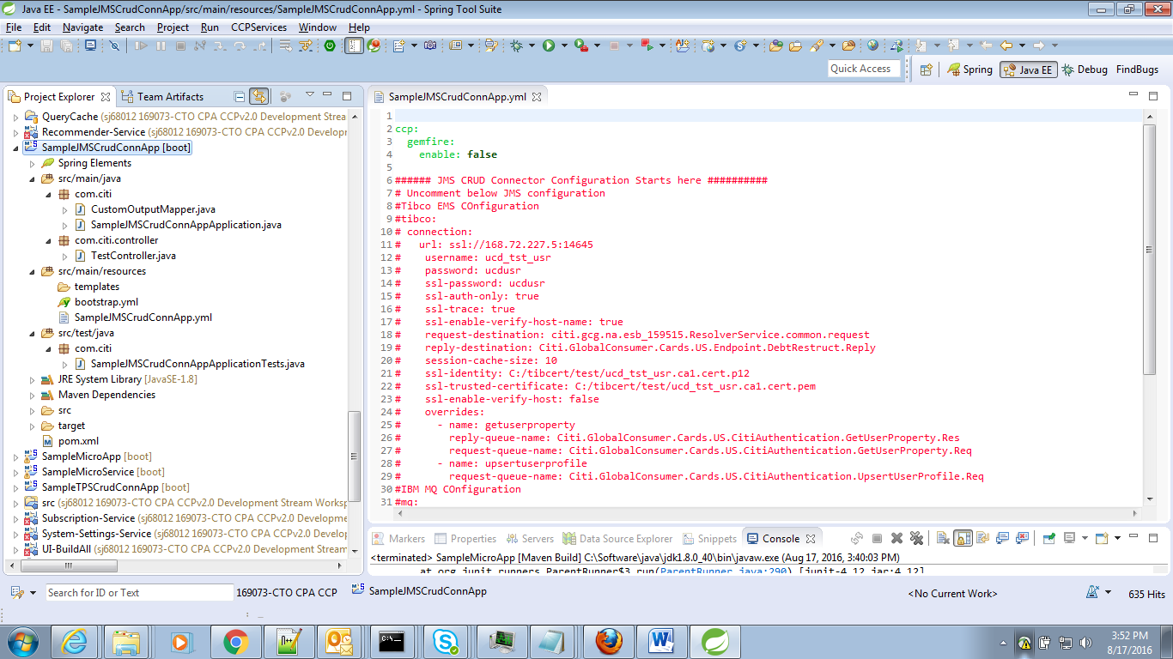

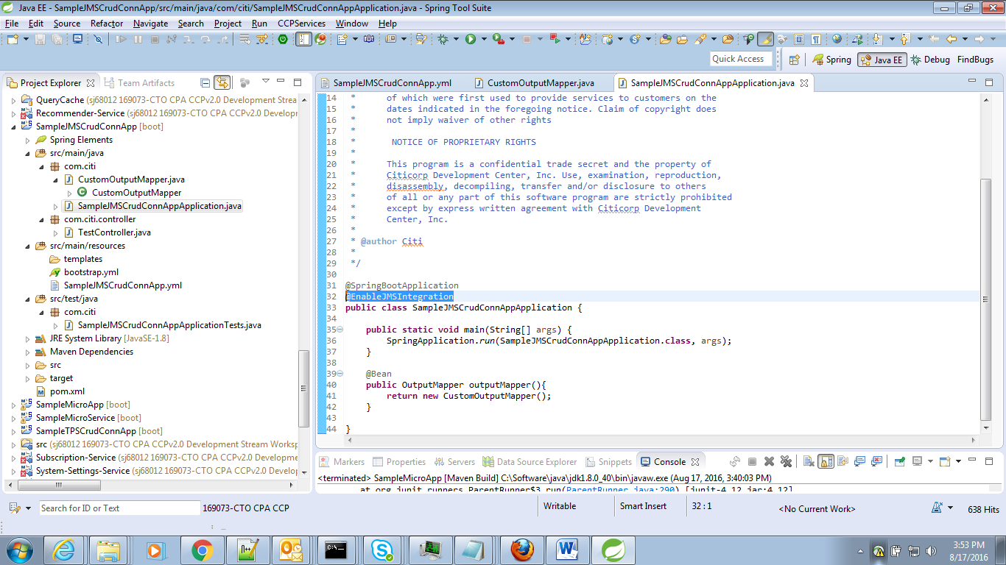

CustomOutputMapper class is created and  bean annotated in Springboot Main Class

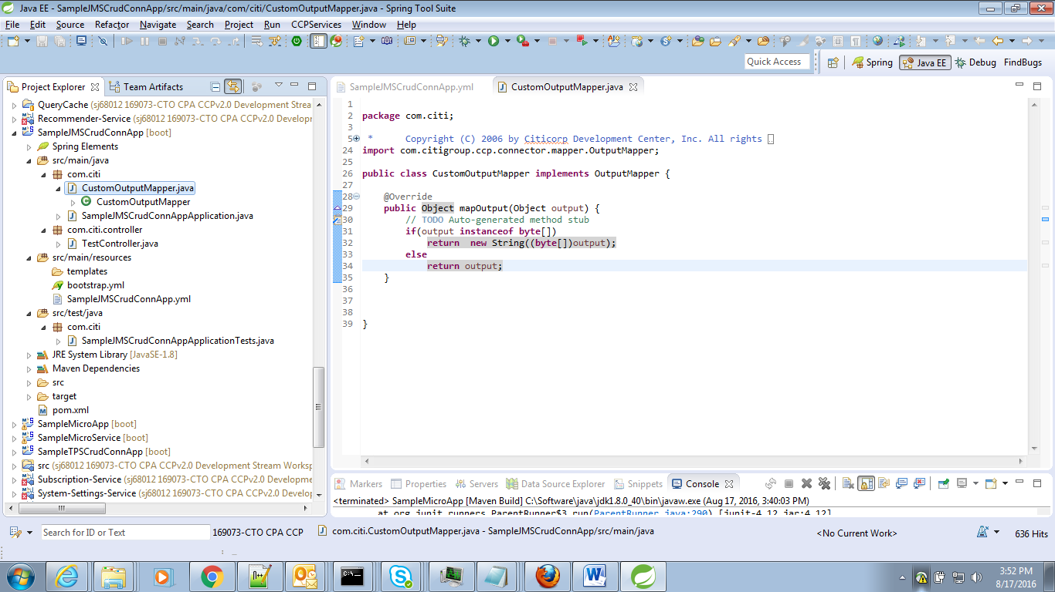

In Controller, ClientJMSGateway is annotated,

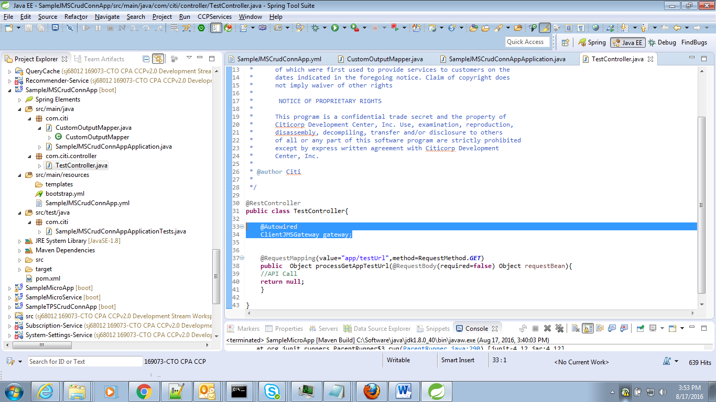

Dependency,

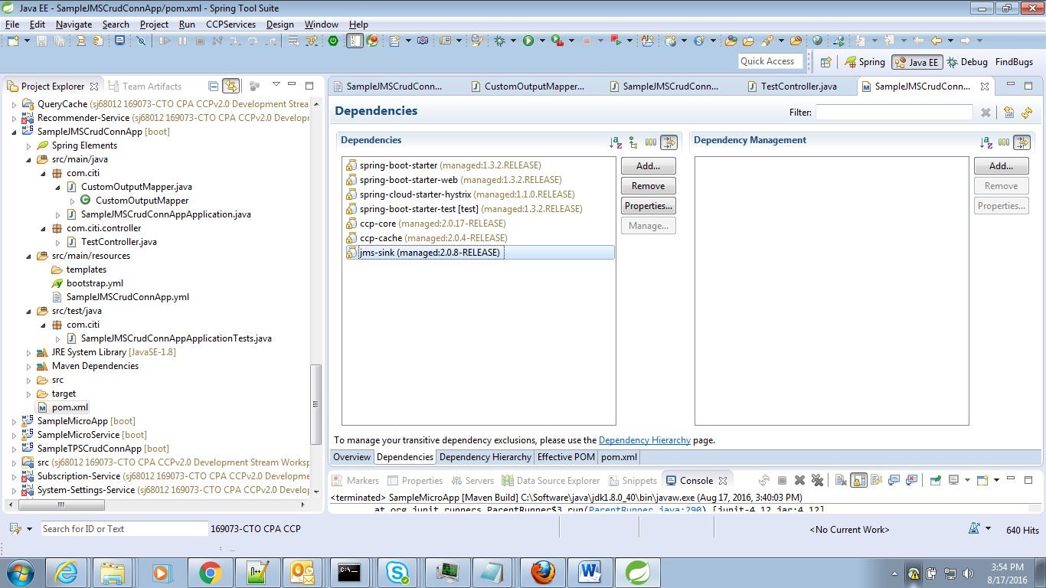

***About Add CCP- Libraries:***

This feature enables user to add the CCP-Libraries any of the existing Micro-Service/Micro-App/Crud-Connector

This will Add the required entries in below files by reading the existing project,

* SprintBoot Application Class
* Controller Class
* <ApplicationName>.yml file,

If there is no <ApplicationName>.yml file found , it will create a new file. If not will update the existing file.

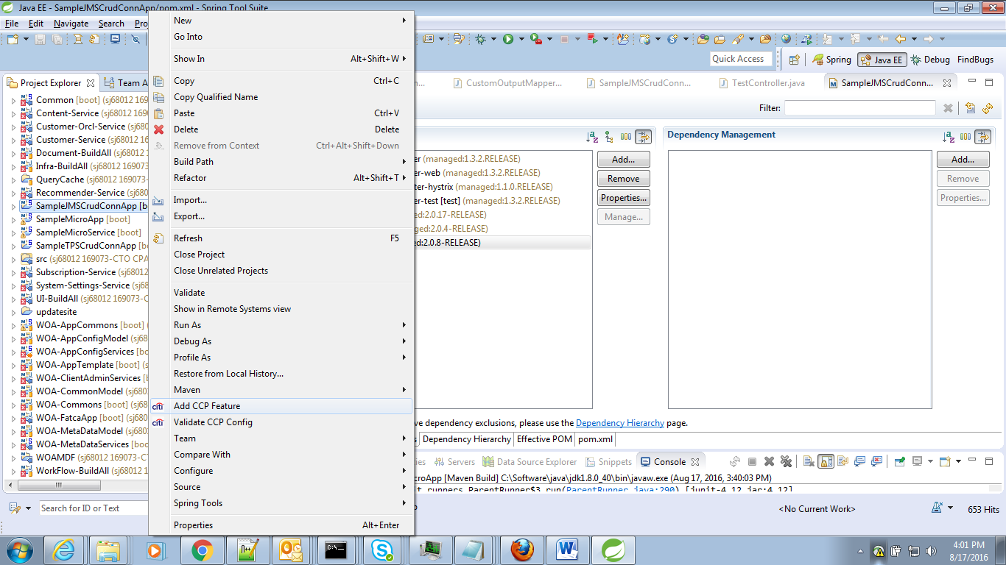

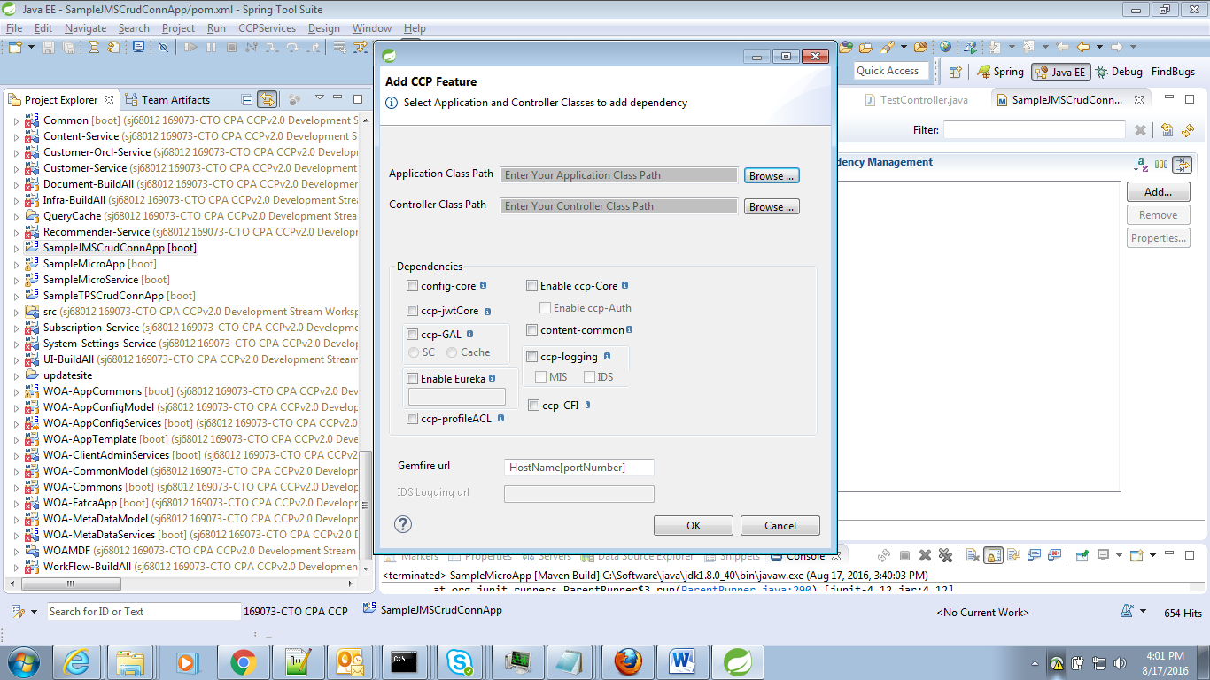

User has to select he SpringBoot Application class and Controller class,

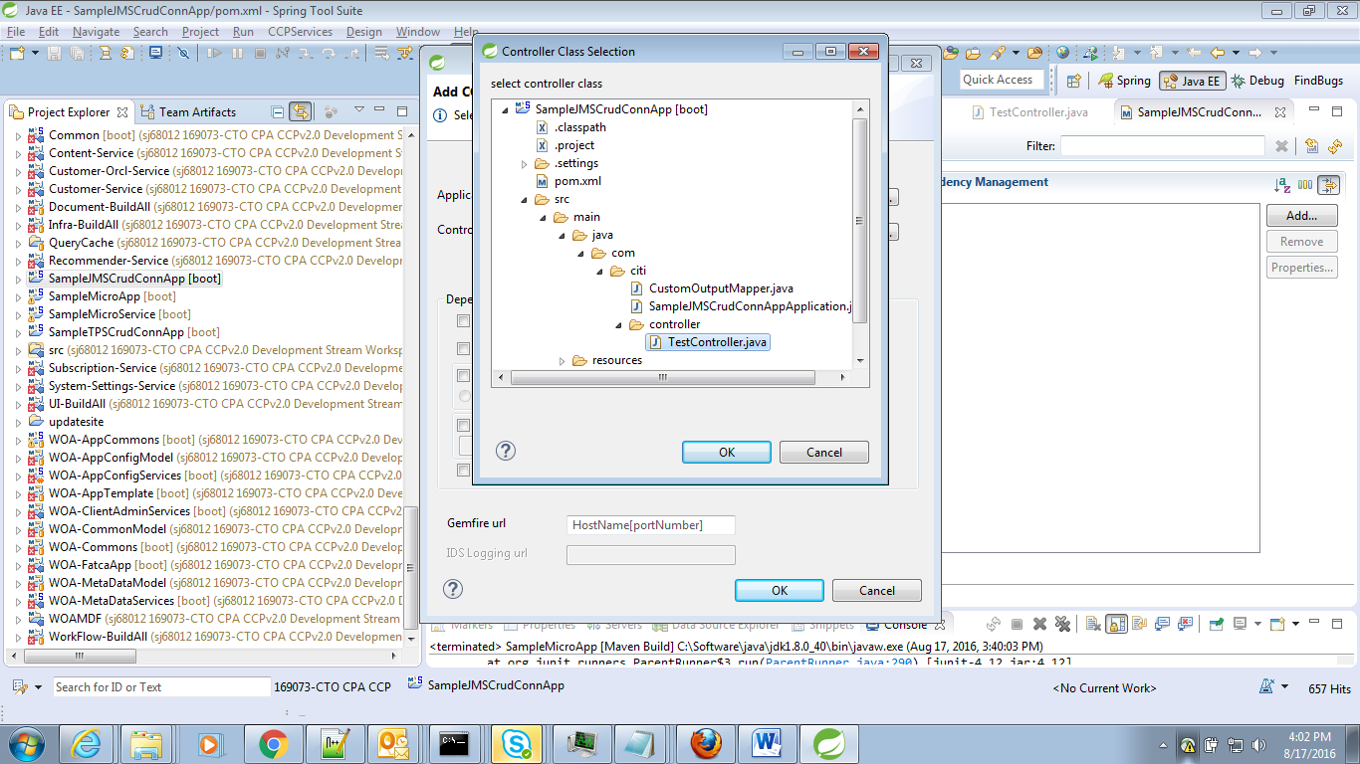

Here GAL is selected to add in the existing JMS project,

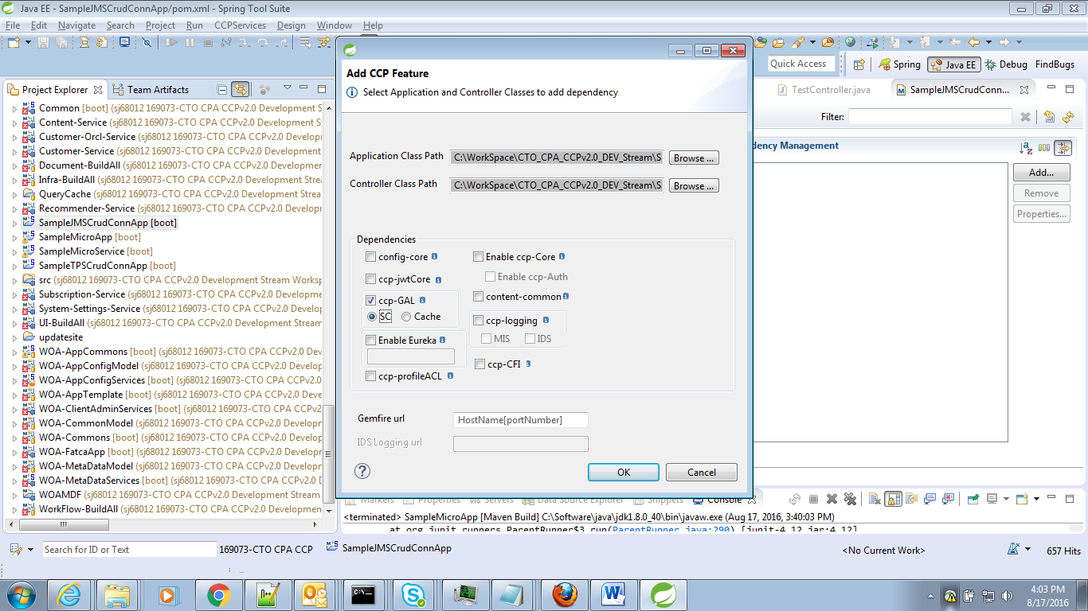

Dependencies,

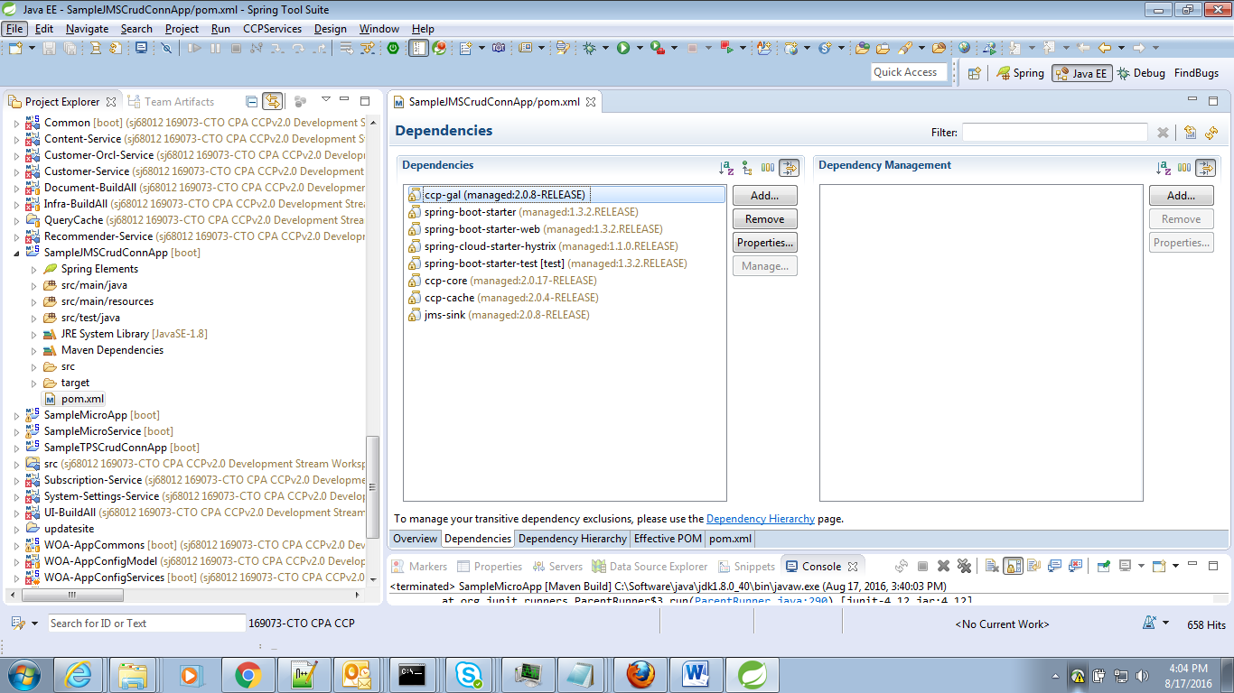

SpringBoot Application class,

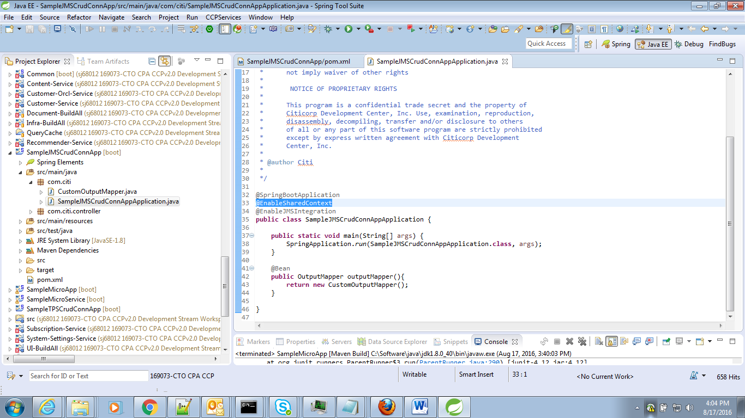

Controller Class,

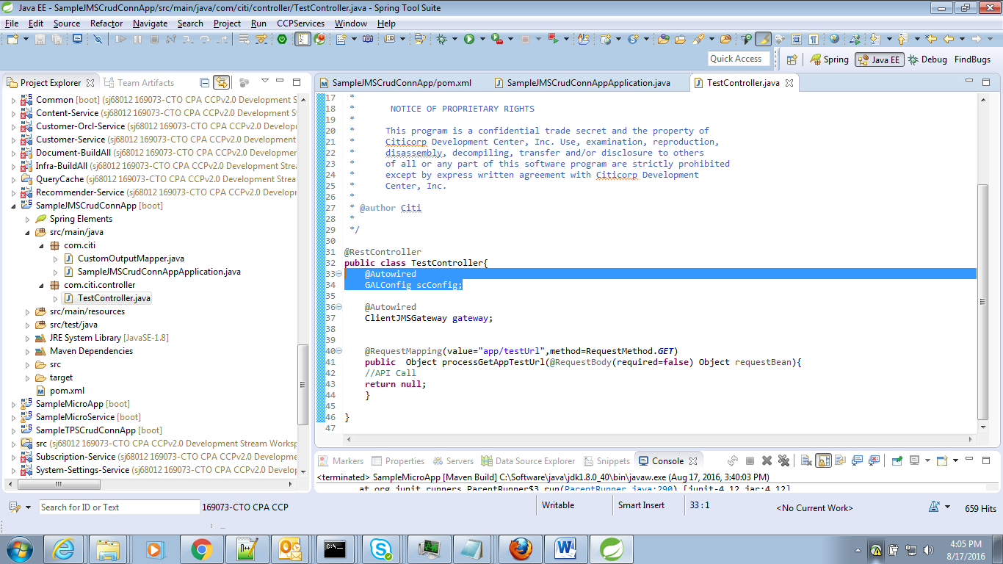

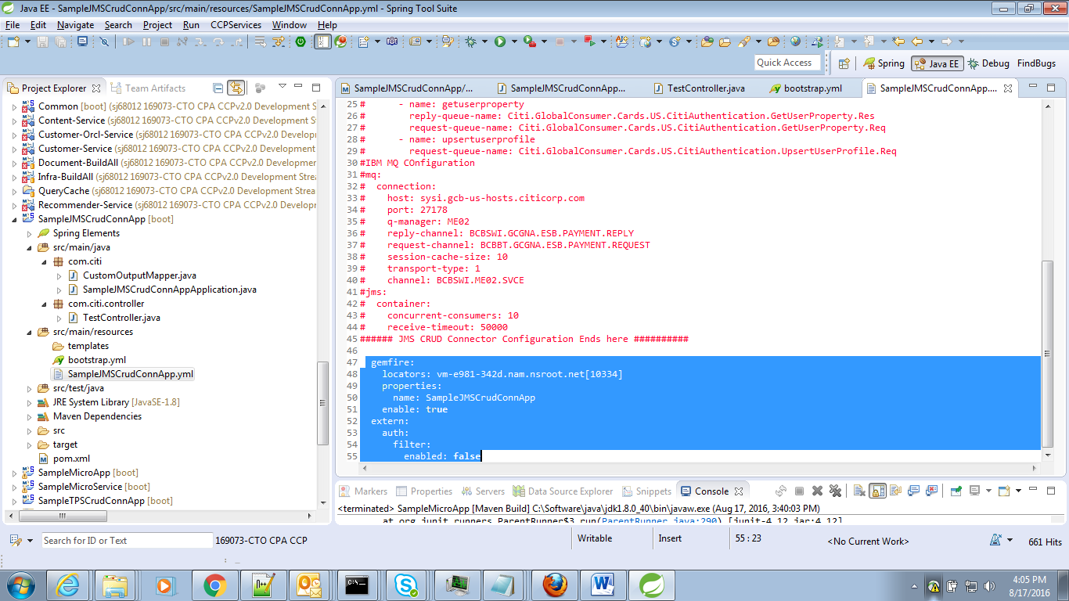

***About Validate CCP- Config:***

This feature will validate the <ApplicationName>.yml file present in the SVN and throw an error if there is any data missing.

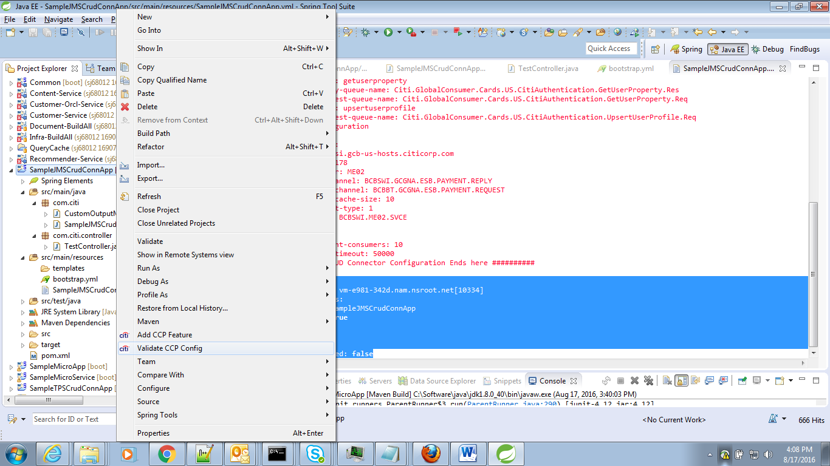

**NOTE: *This is the sample testing, the actual testing has to be done for the corresponding project and its <ApplicationName>.yml file***

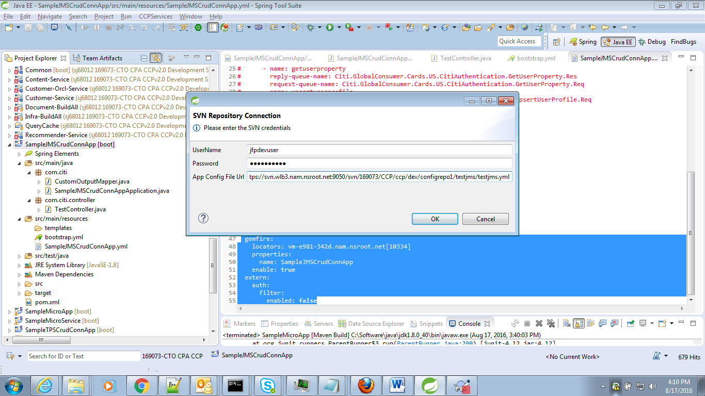

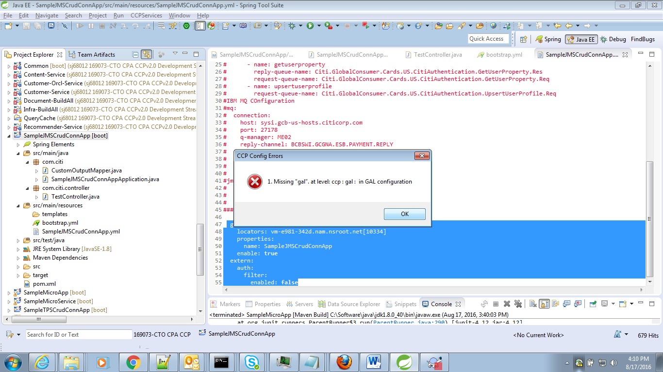

***To Start and Stop CCP-SERVCIES from eclipse:***

This feature will help the developer to start the stop the services from eclipse itself,

This will get the version details from the user, download the jar/war from Nexus and run .

*CCP-SERVICE Menu🡪 Select CCP-Service🡪Start*

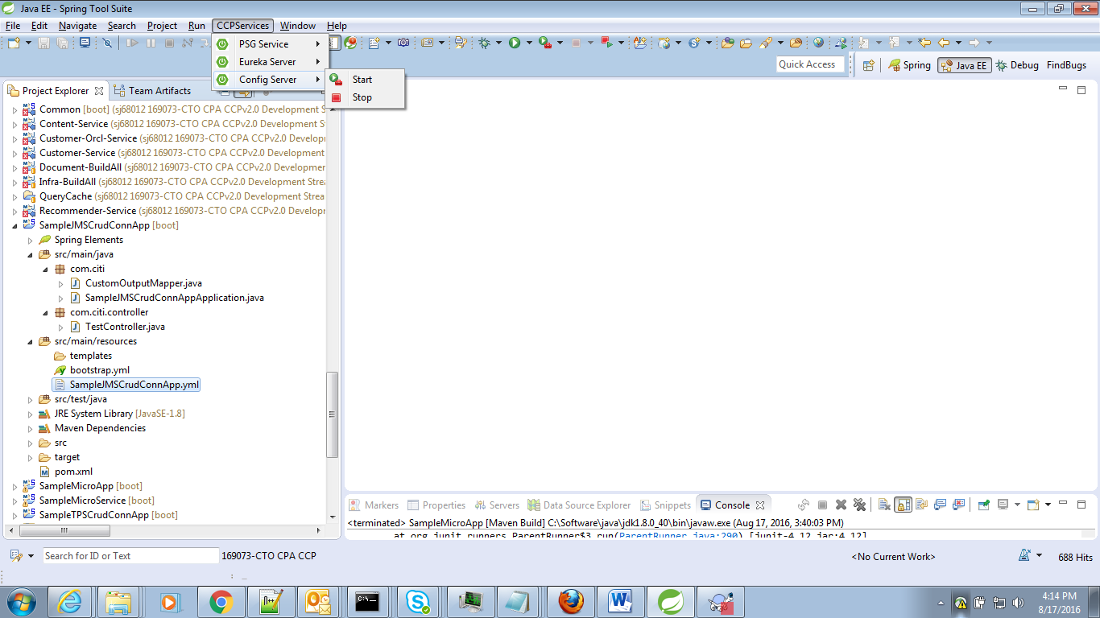

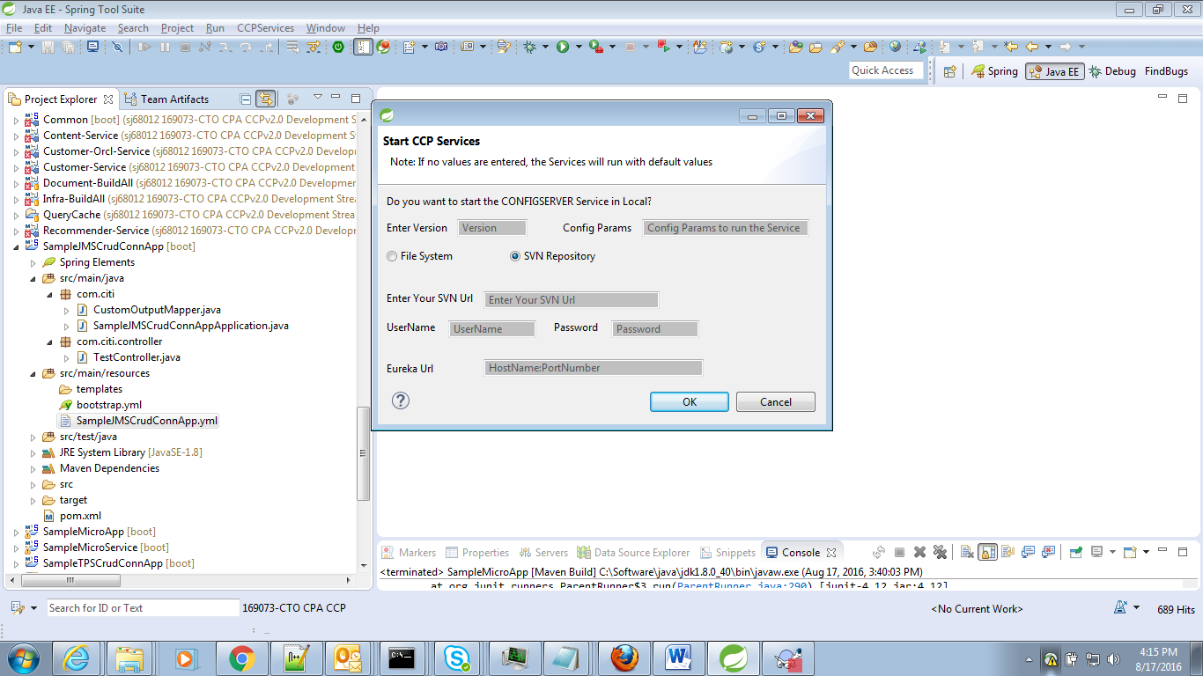

If the user doesn’t enter any values, the service will run with the default values.

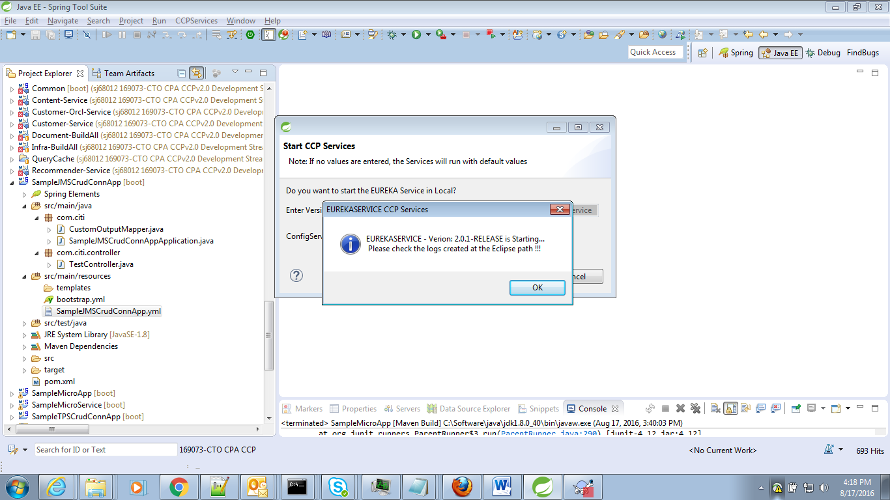

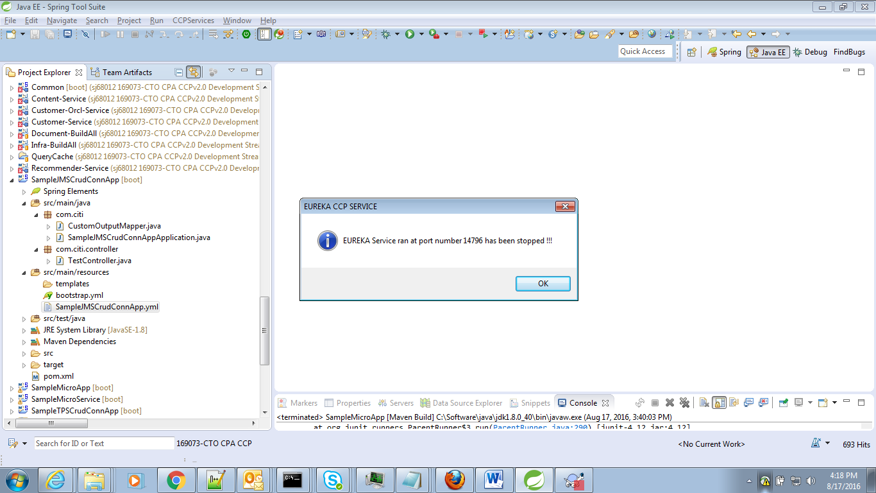

At the background, we can see the logs of the corresponding service,

**Logs path:**

Logs are generated at the STS path,

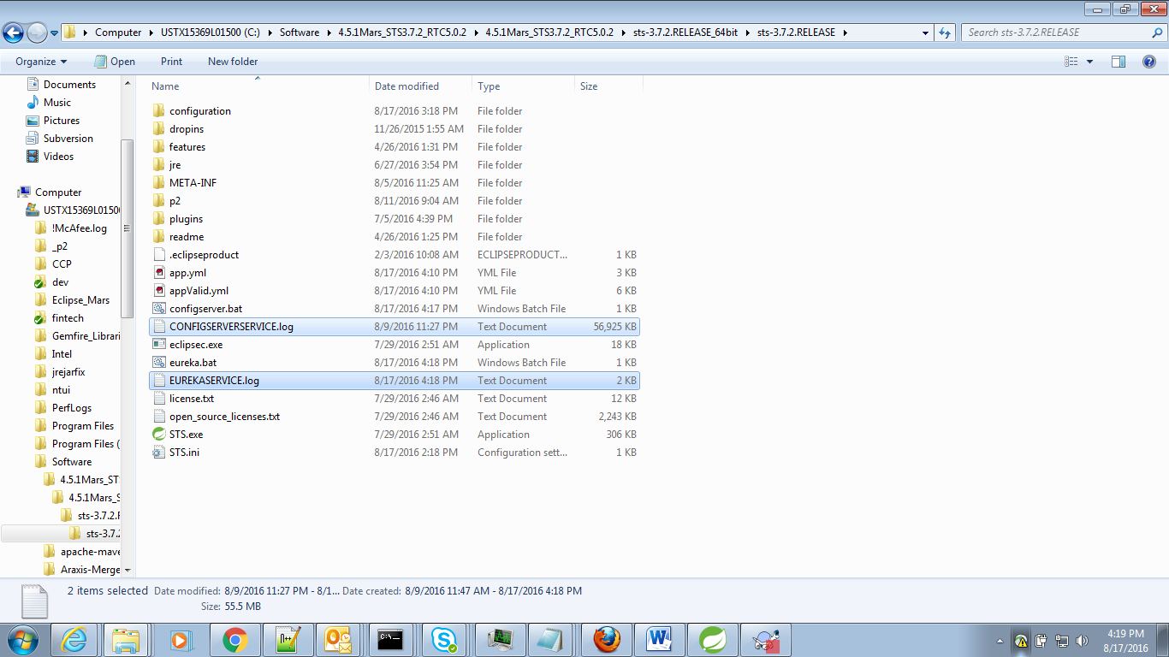

***About NGA Help Content:***

The developer can reach the Help content as below,

HelpMenu→Help Content→ CCP Development Guide

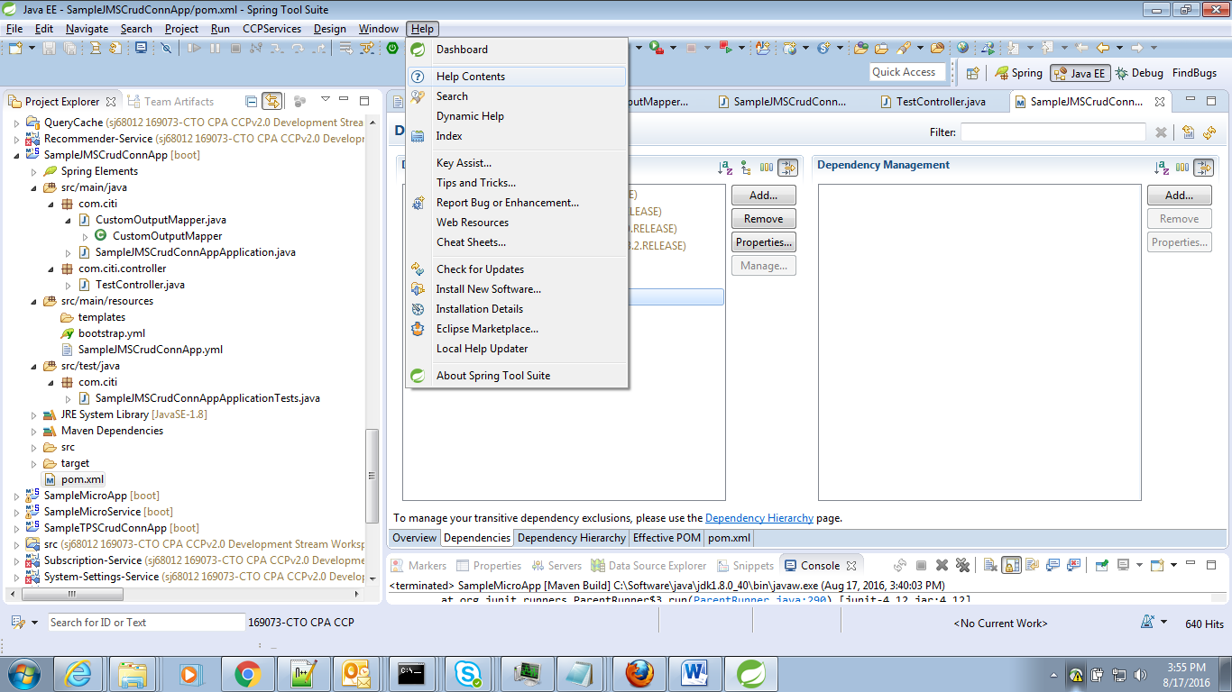

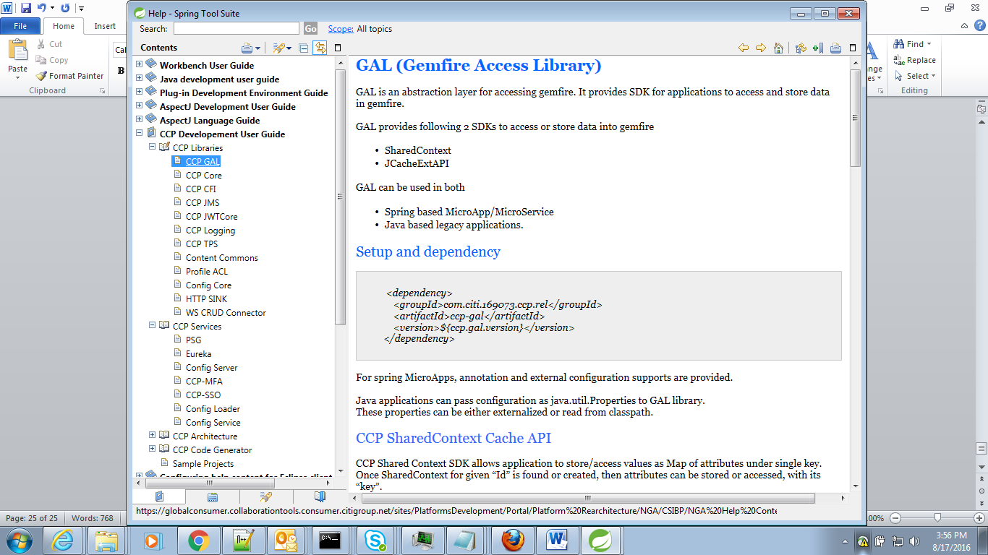

***How to Use CLI- Code Generator Plugins***

CLI plugins are provide with a batch file to execute and generate the Code,

>> CodeGenerator.bat

Execute this batch file,



Rename to CodeGenerator.bat

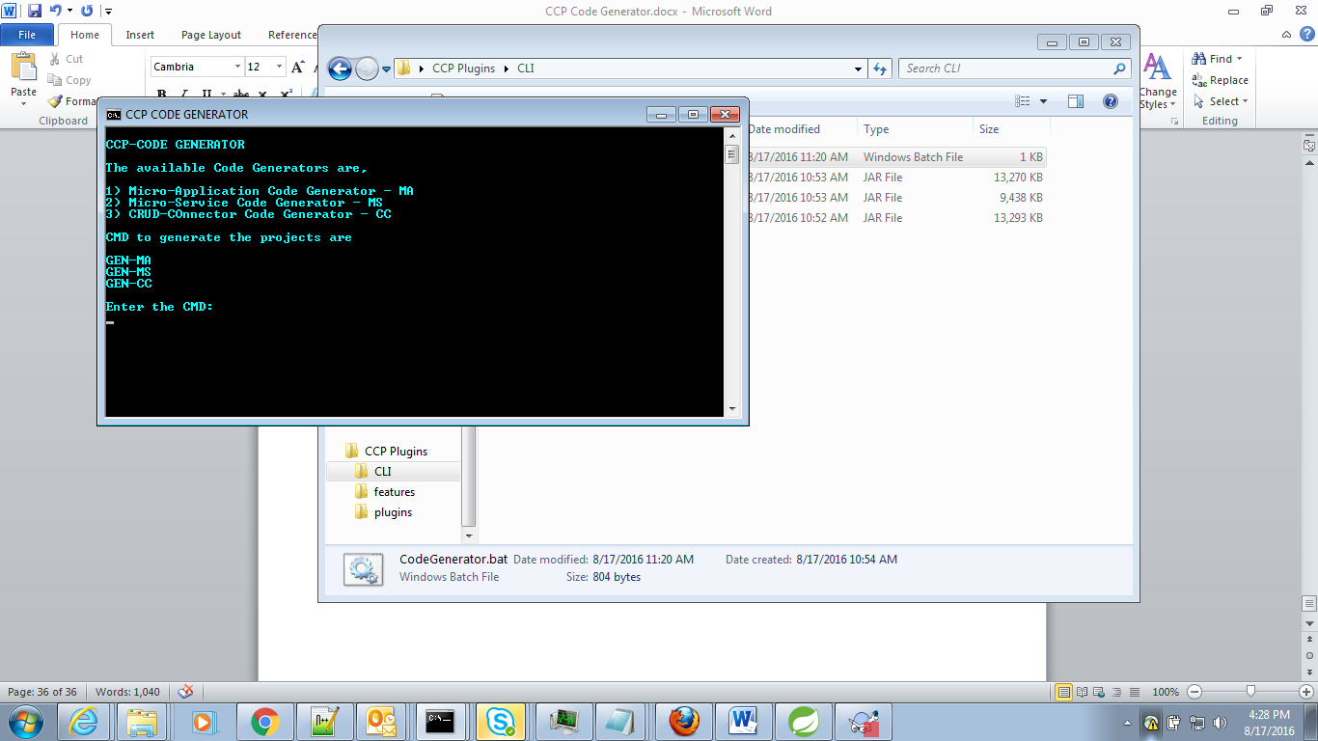

This will display below text,

CCP-CODE GENERATOR

The available Code Generators are,

1) Micro-Application Code Generator - MA

2) Micro-Service Code Generator - MS

3) CRUD-COnnector Code Generator - CC

CMD to generate the projects are

GEN-MA

GEN-MS

GEN-CC

Enter the CMD: __

Enter any of the Command.

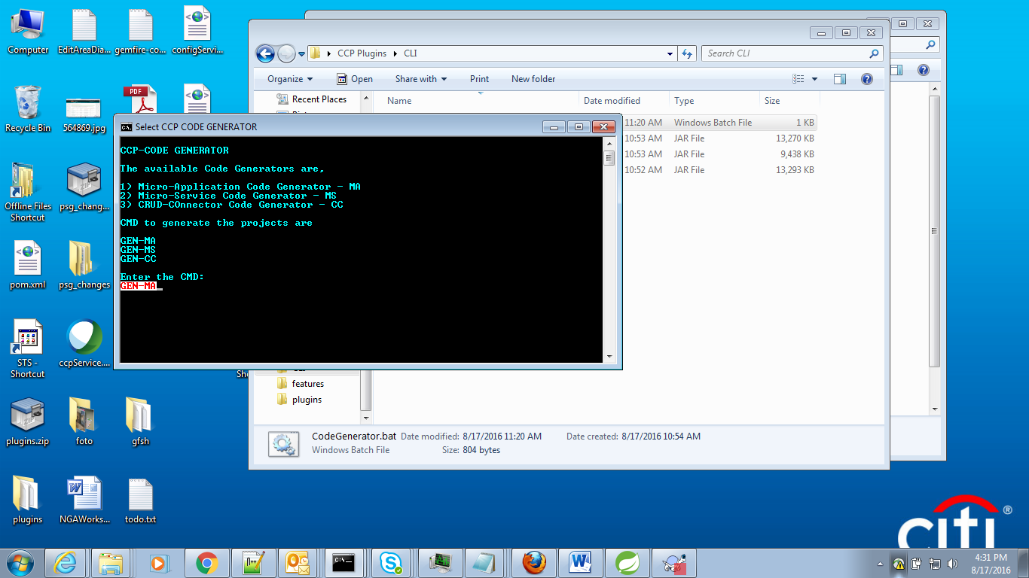

Micro-App Generator:

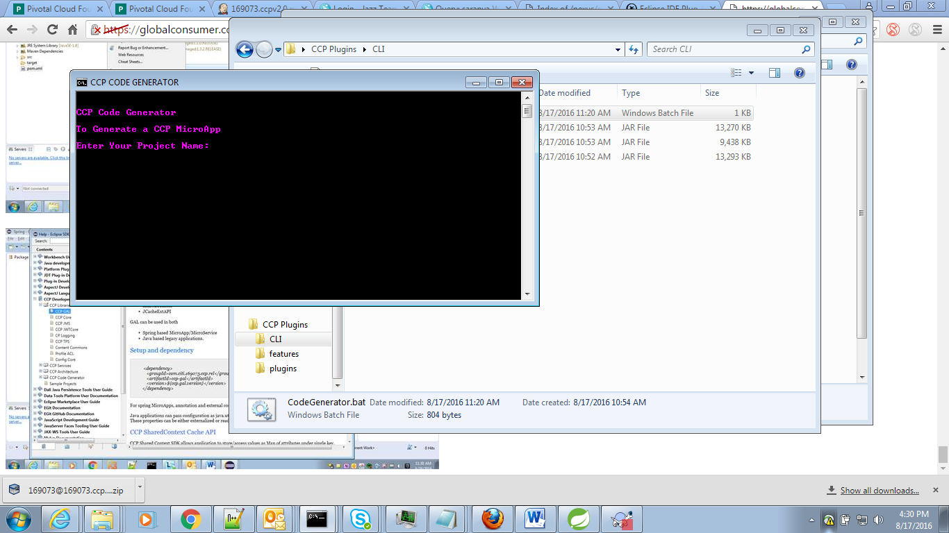

Micro-Service Generator:

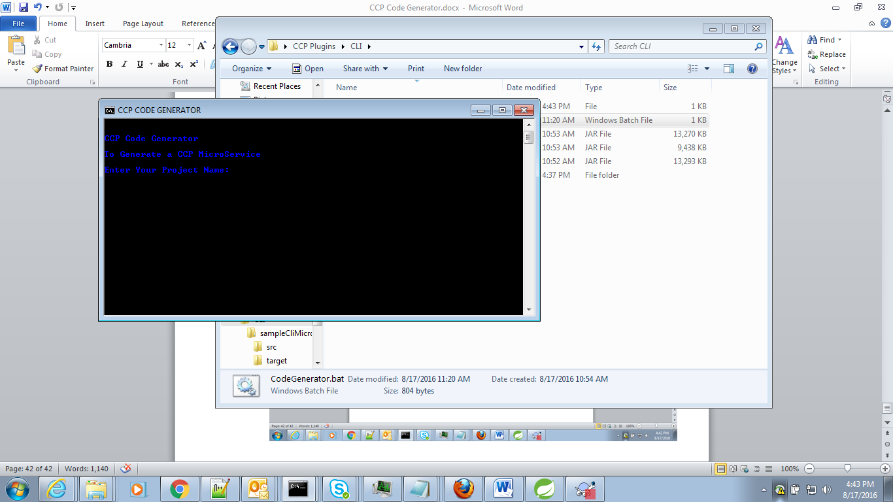

CRUD – Connector Generator:

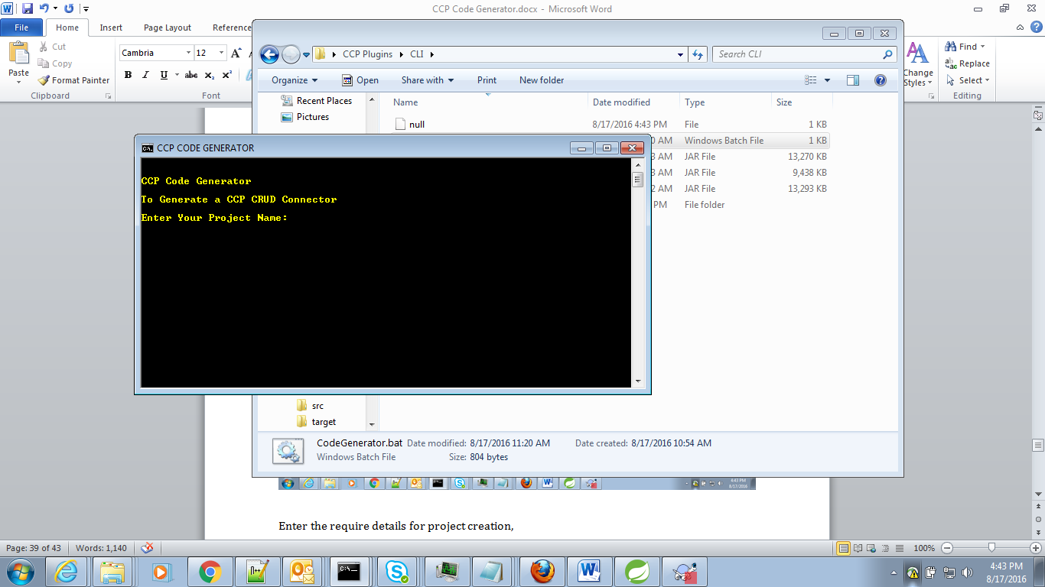

Enter the require details for project creation,

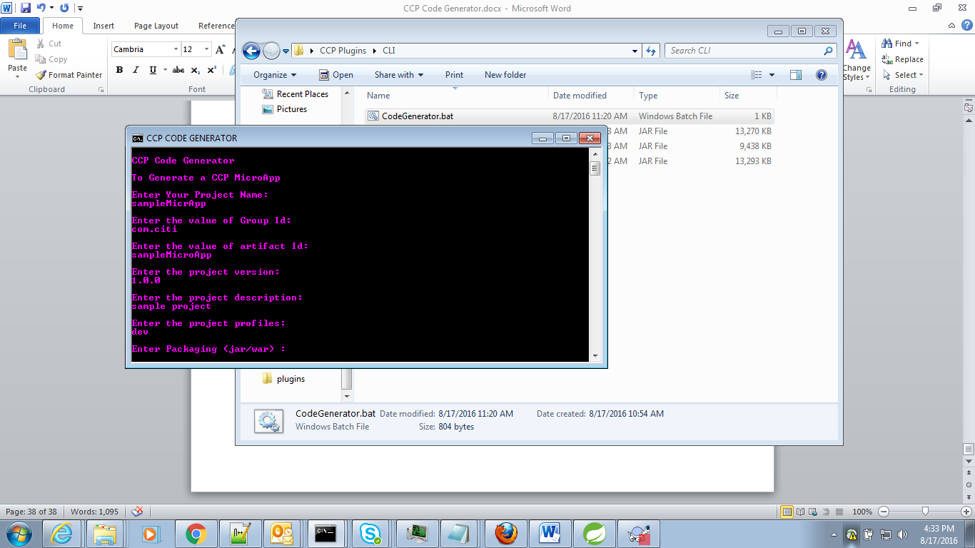

If the User don’t enter values it will take the default value,

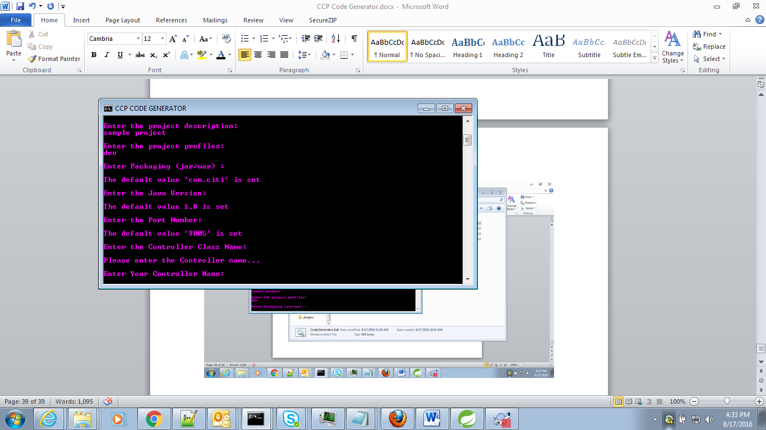

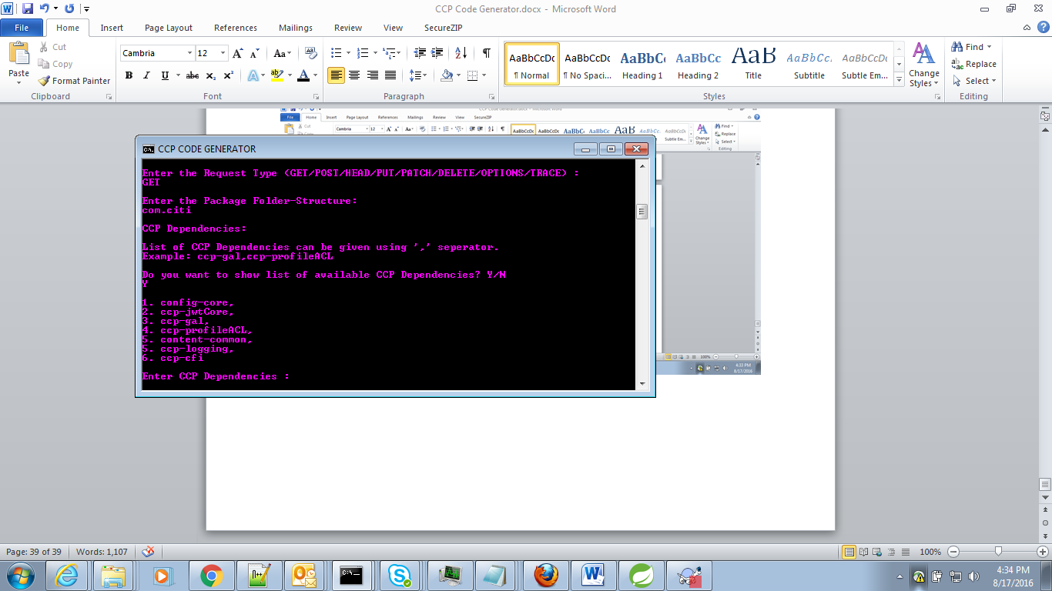

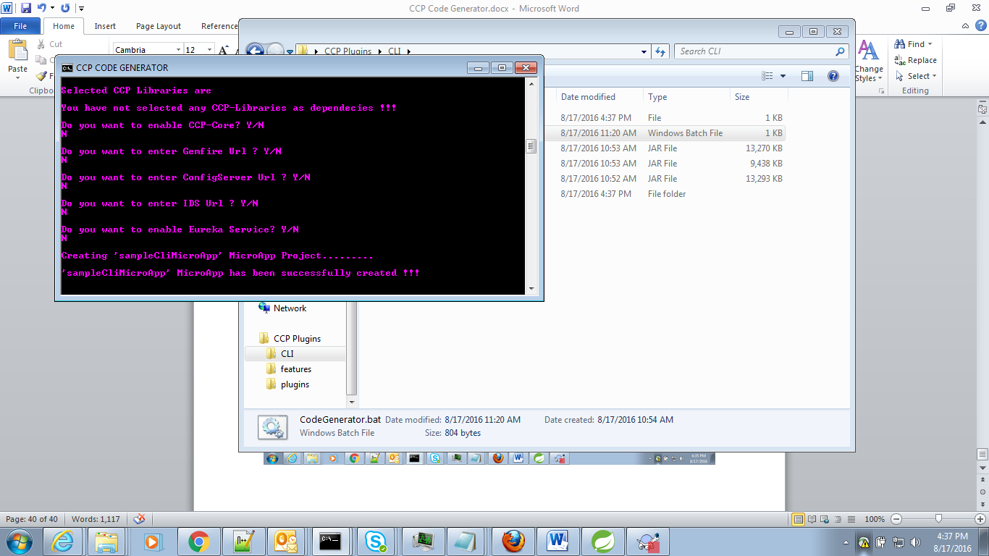

The project will be created in the place from where the batch file is executed,

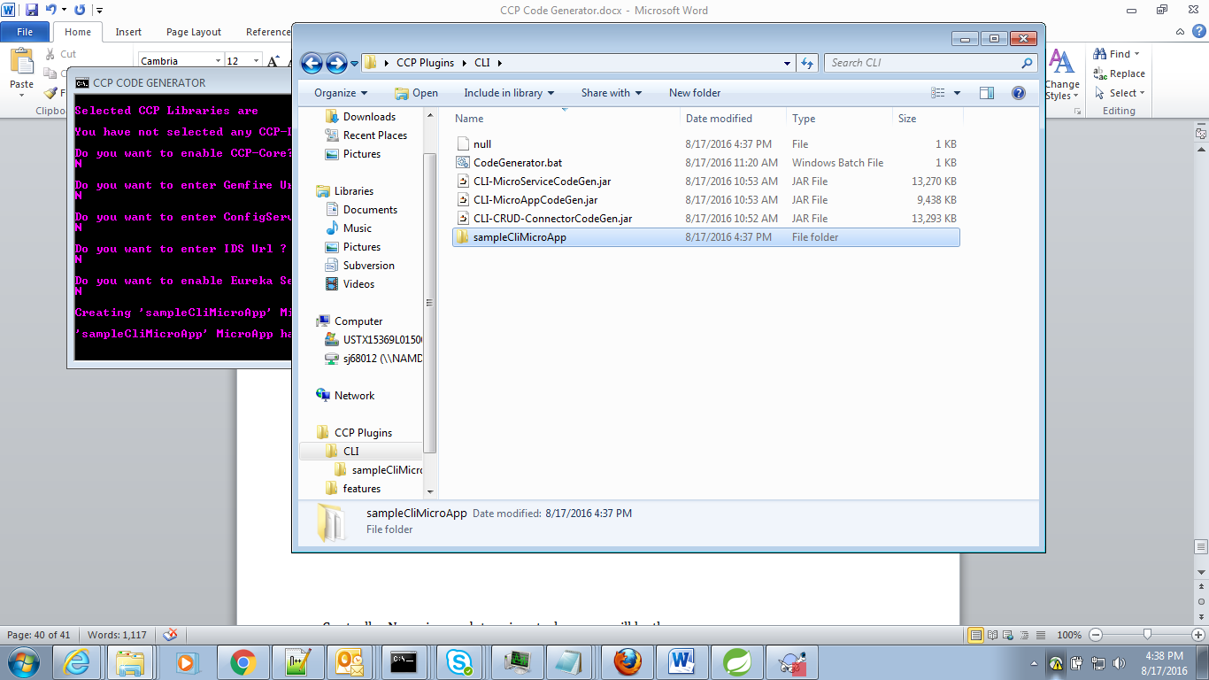

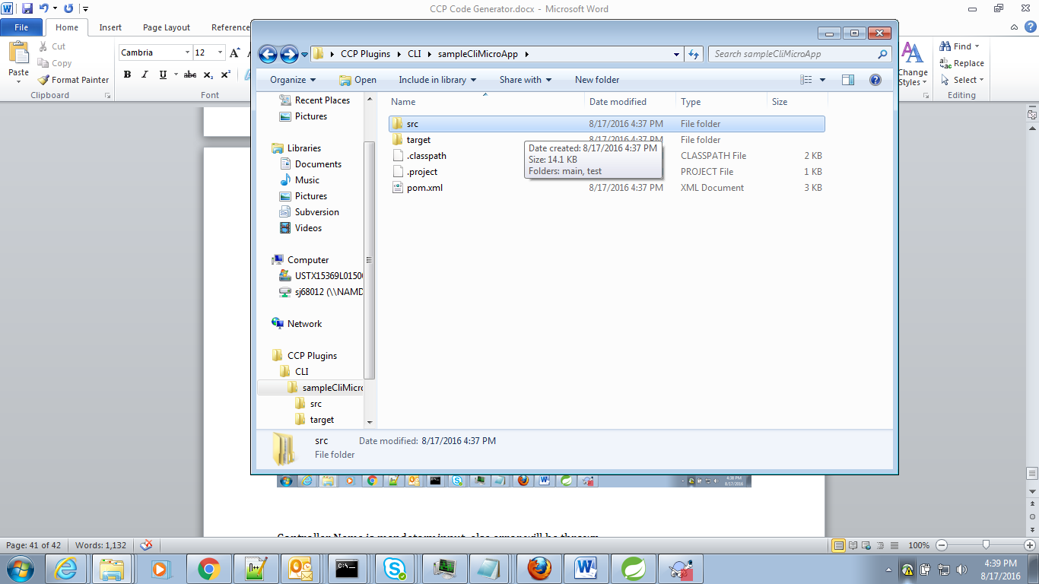

Below are some mandatory params that user has to enter while creating project,

* ProjectName
* Controller Name
* Request Type

